Grand Traverse Band of
Ottawa and Chippewa Indians

Natural Hazards
Mitigation Plan
2023

FEMA Letter of approval

Acknowledgements

This Natural Hazard Mitigation Plan is prepared for the Grand Traverse Band of Ottawa and Chippewa Indians a Native Sovereign Nation. The Plan is a culmination of the interdisciplinary and interagency planning effort the required the assistance and expertise of numerous organizations, departments, and individuals. Without the technical assistance and contributions of time and ideas of these organizations, departments, and individuals, this plan could not have been completed.

Tribal Council 2022

Government Staff

Jolanda Murphy | Public Safety Dept Manager/EM
Eric DePetro | Environmental Division - Marina Shop Stewart
David Crockett | Tribal Police Captain
Russ Cavanaugh | Tribal Police Sergeant
Suzanne McSawby | LE Specialist
Helen Cook | Human Services
Joe Huhn | Public Works Coordinator
Steve Feringa | GTB Project Mgr/Corporate Architect
Rob Kalbfleisch | Land and Roads Mgr
Nicki Basch | Housing Mgr/EM 1st Deputy
Garrett Fairchild | Fire Chief/GTB Fire
Ron Anderson | Facilities Dept. Mgr
George McClellan, II | IT Director
Christy Parker | GTB Gaming Officer
Lori Savaso | Dept. of Risk Management
Jared Sonderegger | Communications Mgr/EM 2nd Deputy
Carolan Sonderegger | NRD Dept Mgr
Jenna Scheub | NRD Environmental Coord.
Becky Oien | TMO
Doris Winslow | TMO
Jodi Lewis | Interim CFO
Mark Wilson | Tribal Vice Chair/PIO
Mari Raphael | Registered Nurse
Soumit Pendharkar | Health Administrator
William Derouin
Sammie Dyal
David Arroyo | Tribal Chairman
Ruth Dudley
Richard Bailey
Christina Loucks | Controller
John Petsokey | General Counsel
Melissa Petoskey | Govt HR
Dawn Shenoskey | Education Dept. Mgr.
Courtney Hessell | NRD Environmental Spec.

Non Tribal Participation

Matt Ansorge | Emergency Management Director
Kelly LaCross | Emergency Management Deputy Director
Clint Mitchell | Leland Township
Joe Musner | Centerville Township
Jim Schwartz | Centerville Township
Dan Besson | Leland Township Fire
Dana Boomer | Kasson Township / Cedar Fire
Andy D | Cedar Township
Amy Fairchild | Mobile Medical Response
Bobbi Scott | Benzie-Leelanau District Health Department
James Kiessel | LCSO
Jim Calhoun | Leelanau County Road Commission
Brendan Mullane | Leelanau County Road Commission
Hugh Cook | LTFD
Trooper Jason Tropf | Michigan State Police
Michael deCastro | Michigan State Police
Nick Florip | Harbor Hill Fruit Farm

Prepared for the Grand Traverse Band of Ottawa and Chippewa Indians
with assistance from:



Networks Northwest
PO Box 506
Traverse City MI 49685-0506
Telephone: 231.929.5000
www.networksnorthwest.org

Table of Contents

Acknowledgements 3
Table of Contents 5
I. Introduction 6
II. Planning Process 7
II. Community Profile 13
III. Hazard Identification and Assessments 27
IV. Goals and Objectives 55
V. Mitigation Strategies and Priorities 56
VI. Implementation 58
Appendix A: GTB Infrastructure, Vulnerability, and Hazard Maps 59
Appendix B: Community Survey Results 60
Appendix C: Local Planning Team Meeting Documentation 61

Introduction

Hazard mitigation is defined as any action taken before, during, or after a disaster or emergency to permanently eliminate or reduce the long-term risk to human life and property from natural, technological and human-related hazards. Mitigation is an essential element of emergency management, along with preparedness, response and recovery.

The fourth element of emergency management, mitigation, can lessen the need for a community to respond to subsequent hazard events, for some incidents may remain as mere incidents and not become disasters. Mitigation allows repairs and reconstruction to be completed after an incident occurs in such a way that does not just restore the damaged property as quickly as possible to pre-disaster conditions. It also ensures that such cycles are broken, that post-disaster repairs and reconstruction take place after damages are analyzed, and that sounder, less vulnerable conditions are produced. Through a combination of regulatory, administrative, and engineering approaches, losses can be limited by reducing susceptibility to damage. When successful, hazard mitigation will lessen the impact of a disaster on people, property, the environment and economy, and continuity of services through the coordination of available resources, programs, initiatives, and authorities.

A hazard, in the context of this plan, is an event or physical condition that has potential to cause fatalities; injuries; damage to personal property, infrastructure, or the environment; agricultural product loss; or interruption of business or civic life. The Grand Traverse Band of Ottawa and Chippewa Indians Natural Hazard Mitigation Plan focuses on natural hazards such as heat, drought, wildfires, flooding, shoreline erosion, thunderstorm, high winds, hail, and extreme winter weather. An exception is that it will also consider these technological and human-related hazards: dam failure, public illness outbreak, and invasive species.

The main objective of the Plan is to permanently eliminate or reduce long-term risks to people and property from natural hazards so that Tribal assets such as infrastructure, commerce, and housing can be sustained and strengthened. This can be accomplished through collaborative efforts/activities amongst agencies within the government to protect the health, safety, and economic interests of the residents and businesses through planning, awareness, and implementation.

Through this Plan, a broad perspective was taken in examining multiple natural hazard mitigation activities and opportunities for protecting the Grand Traverse Band of Ottawa and Chippewa Indians Tribal (GTB) community from future hazard events. Each natural hazard was analyzed from a historical perspective, evaluated for potential risk, and considered for possible mitigation.

The GTB is adopting an update to their 2016 Hazard Mitigation Plan that meets the requirements of Title 44 of the Code of Federal Regulations, Section 201.7. A FEMA-approved hazard mitigation plan is required for receiving certain types of non-emergency disaster assistance, including funding for Hazard Mitigation Assistance projects and Public Assistance permanent work (categories C-G) for Tribal governments applying directly to FEMA for assistance. The Plan includes a description of the planning process, a description of the community, hazard identification and analysis, current mitigation capabilities, a strategy and action plan, and a process for incorporating the plan into other Tribal processes and updating the Hazard Mitigation Plan. The mitigation strategies are intended to be action items completed during the 5-year timeframe the plan is active.

Recognizing the importance of reducing community vulnerability to natural hazards, GTB is actively addressing the issue through the development and implementation of this plan. This process will help ensure that Tribal community remain a vibrant, safe, enjoyable place in which to live, raise a family, continue to conduct business. The Plan serves as the foundation for natural hazard mitigation activities and actions within Leelanau County and surrounding areas, and will be a resource for building coordination and cooperation within the community for local control of future mitigation and community preparedness around the following:

Planning Goals:

Planning Process

The Stafford Act, as amended by the Disaster Mitigation Act of 2000, shifted the Federal Emergency Management Agency’s (FEMA) scope of work to promoting and supporting prevention, or what is referred to as hazard mitigation planning. FEMA requires Tribal nations to have a natural hazards mitigation plan in place and updated on a 5-year cycle as a condition for receiving grant money related to natural hazard remediation. The Grand Traverse Band of Ottawa and Chippewa Indians are adopting a Hazard Mitigation Plan that meets the requirements of Title 44 of the Code of Federal Regulations, Section 201.7. The adoption of the 2022 plan will affirm the Tribe’s eligibility for federal funding.

The creation of the Tribe’s plan was led by the Natural Hazards Task Force comprised of the Tribal Local Planning Team (LPT). Team members consist of Tribal Councilmembers, emergency response personnel, and government staff that ensure the readiness of the Tribe by recommending equipment purchases, training and exercises, and member education on preparedness issues. Networks Northwest assisted with the planning process and provided support to facilitate meetings and plan writing. The Task Force met regularly virtually and inperson at ###. The following is an outline of events for the development of the 2022 Natural Hazard Mitigation Plan:

- On July 1, 2021, Jolanda Murphy and Garrett Fairchild attended a project kick off meeting with county and tribal emergency managers.
- On October 21, 2021 Networks Northwest attended a LPT meeting and provided an introduction and timeline for the project. The meeting was held virtually.
- In October 2021, the Tribe released an online community survey. More details about the survey are below.
- On January 14, 2022 Networks Northwest presented the community profile information and provided a summary of preliminary survey results. The meeting was held virtually.
- On March 11, 2022 Networks Northwest presented the final survey results and the hazard analysis including historic weather events. The meeting was held virtually.
- On April 14, 2022 a joint community meeting was held between Tribal officials and representatives from Leelanau County to discuss potential hazards. The meeting was held in person.
- On August 18, 2022 the LPT met to discuss the partial draft plan, goals and objectives, and hazard mitigation strategies.

Community Survey Results

The primary source of feedback was gathered through the Community Survey. The survey was shared electronically and available in an online format from October to November 2021. The survey asked 14 questions related to hazard mitigation and received 120 responses. The first question asked participants to identify their role in the GTB community. The majority of participants were government employees and/or citizens.

Responses to Question 2 asked how familiar participants were with the existing Natural Hazard Mitigation Plan. The majority (73%) were not familiar with the plan. However, Question 3 asked how concerned participants were with natural hazard events impacting their community. 51.67% were “somewhat concerned” and 41.67% were “very concerned.” Responses to Question 4 largely represent the primary concern of the time, the Covid-19 Pandemic. For example, when asked what natural hazard event is likely to have the largest impact on your community, 77 of 119 responses were related to pandemic/illness outbreak or lack of outbreak resources. Other responses included snowstorms/winter storms/blizzards, and major or sever weather storms, especially those causing power outages (34 responses), flood (22 responses), and wildfire (16 responses), Tornado, drought, invasive species, and water contamination were mentioned less frequently.

Questions 5 asked about community concerns for infrastructure and what forms of investment might be required to mitigate natural hazards. 46 of 117 responses said no or were unsure if infrastructure was a concern. Of those who responded that infrastructure is a concern, many participants were concerned about power outages and the need for back-up power. For example, the survey received the following response, “Power lines in weather events have shut things down for up to a week a few times in the last decade or so with no power.” Bridges and dams were also frequently mentioned and the concern about flooding damages. One participant said, “Yes. Many local dams and road stream crossings were designed and constructed decades ago and under hydrologic regimes that are now rapidly shifting towards more frequent and of higher intensity. Further, many stormwater and wastewater systems are also rapidly becoming outdated given these climate related hydrologic regime shifts. Much more funding needs to be directed towards assessment and re-design and construction of substandard infrastructure.”

Similarly Question 6 asked what are the concerns there are for required investment in infrastructure and technology. 27 responses said no or were unsure about required infrastructure upgrades. 23 responses indicated renewable energy is potential investment to upgrade infrastructure and reduce the impact of a natural hazard. Other infrastructure that was mentioned included roads, bridges, stormwater management, and wireless and internet service. For example, one response said, “Yes, internet service needs to be improved in Peshawbestown as well as other rural areas. Renewable energy / energy independence would benefit the tribe. Existing buildings are older and may not be the most energy efficient.”

In Question 7, 55 of the 117 participants who provided a response said no or were unsure if there have been any negative impacts on the public health and/or natural environment of their community that are attributed climate change. A few of those who responded they were unsure, did request additional information. Of those who responded in the affirmative, many associated climate change to public health concerns such as poor air quality, water quality, illness outbreaks, increased precipitation, high water levels, milder winters, hot summers, and the influx of invasive species. Several responses identify a chain reaction between unusual or uncommon weather patterns and effects on plant and animal species.

Questions 8-12 asked about participants’ familiarity with hazard mitigation planning. 89% said they were not involved in the previous planning process. Question 9 asked if participants were familiar with requests for assistance for mitigation projects in the past. 85% were unknown as to whether or not requests have been made. In a follow up question, Question 10, asked if the request was granted: 87 of 93 responses were, “unknown” or not applicable. Question 11, asked if the community has considered mitigation strategies for potential hazards. 83% of responses were “unknown.” In the follow up question, Question 12, ask participants to identify potential mitigation strategies. 58 of 88 responses were, “unknown” or not applicable. However, several responses included ideas such as renewable energy opportunities, providing back up power sources, providing education and training, providing emergency shelters, improving infrastructure and installing underground power lines, and maintaining and increasing native habitats especially water draining areas such as wetlands, streams, and drainage paths.

Question 13 asked if there was any additional information to be considered for the Tribe’s Natural Hazard Mitigation Plan. First and foremost, participants requested transparency and information. Preparedness was also mentioned several times. One participant asked to include all six county areas for inclusion in the plan. Another asked to consider age-related circumstances and current methods of communication such as the website. Several responses asked for the plan to reflect cultural appreciation of lands/property as well as Tribal values. Participants also suggested addressing Tribal needs and getting everyone the help they need. In a separate comment, a responder asked to consider community displacement from heavy snow storms.

The final question, Question 14, asked survey-takers to respond with their contact information if they wish to be involved with the plan process. Several responses included a name, email address, and phone number to contact those who are interested. Many indicated no, they are not interested.

Draft Plan Review and Comment

Upon approval by the Natural Hazards Task Force, the plan was released for review and comment. A notice of availability was published in the “ “ and government staff and the entire membership were encouraged to view the plan and submit suggestions and ideas for updates, changes to be considered during updates.

Additionally, county and regional agencies that share jurisdictional boundaries with the Grand Traverse Band of Ottawa and Chippewa Indians were provided the opportunity to formally comment on the draft plan and other related materials. A copy of the plan in its draft form was published openly on the GTB’s website and Networks Northwest’s website. Those agency staff members are:

- Emergency Manager, Little Traverse Bay Band of Odawa Indians
- Brandy Martin, Incident Commander, Little River Band of Ottawa Indians
- Leslie Meyers, Emergency Operations Director, Antrim County
- Rebecca Hubers, Emergency Management Coordinator, Benzie County
- Sienna Wenz, Emergency Management Coordinator, Charlevoix County
- Matt Ansorge, Emergency Management Director, Leelanau County
- Mike Machen, Deputy Director/Emergency Management Coordinator, Leelanau County
- Gregg Bird, Emergency Management Coordinator, Grand Traverse County
- Robert Carson, Regional Director of Community Development, Networks Northwest

While no formal written comments were received, the Public Safety Department Manager and Emergency Manager received feedback via other informal means. This feedback took the form of phone calls, emails and conversations that occurred at various non-mitigation related meetings.

The public was notified through a published notice in the ### on ###, 2023 of the Tribe’s draft Hazard Mitigation Plan and the opportunity to provide feedback at the public hearing held on (date). The draft plan was made available on the Tribe’s website as well as Networks Northwest’s website. Below are images of the websites for the available draft plan and a copy of the published notice to the public.

Website Image
Source: Grand Traverse Band of Ottawa and Chippewa Indians’ website (date)

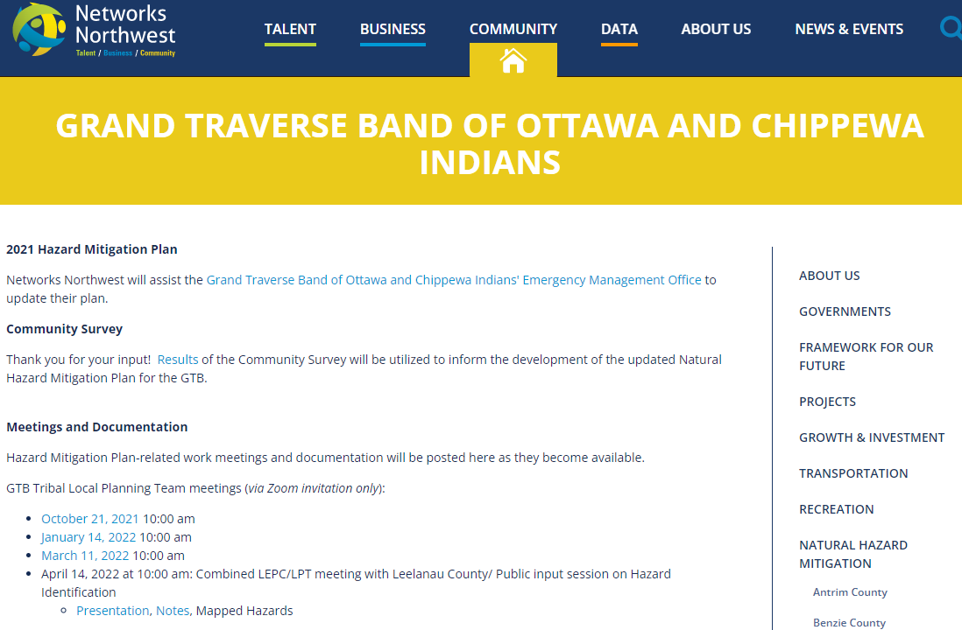
Source: Networks Northwest website (date)

Community Profile

The Grand Traverse Band of Ottawa and Chippewa Indians (GTB or the “Tribe”) is a Federally-recognized Native Sovereign Nation. The Anishinaabek are the people of the Three Fires Confederacy, the Odawa (Ottawa), the Ojibwa (Chippewa), and the Bodowadomi (Pottawatomi) people. The oral history traces back to the Eastern Coast of Turtle Island where the spiritual leaders told ancient peoples to travel to the west until they found the food growing on the water. When they travelled west native people found wild rice growing on the water and they knew they were home. The GTB had its status as a federally recognized Indian tribe reaffirmed and restored by the United States in 1980. The Tribe has a government-to-government relationship with the United States by action of the Department of the Interior effective May 27, 1980.

Location

The Grand Traverse Band of Ottawa and Chippewa Indians Tribal lands are located in northwest lower Michigan, across six counties: Antrim, Benzie, Charlevoix, Grand Traverse, Leelanau, and Leelanau Counties (Figure 1). The GTB’s reservation and service area covers an area of 2,562 acres. The GTB land base is designated as rural by the U.S. Department of Agriculture. The GTB continues to purchase land within these areas for historical, spiritual, environmental, economic, and development purposes. The majority of Tribal facilities are concentrated in Peshawbestown in Leelanau County.

Figure 1: Grand Traverse Band of Ottawa and Chippewa Indians Service Area

Source: Grand Traverse Band of Ottawa and Chippewa Indians

Table 1: GTB Land, Trust and Non-Trust
Source: Grand Traverse Band of Ottawa and Chippewa Indians Land Records

Recent History of Land Use

We were traders and established trade routes as far east as the Atlantic Ocean, as far west as the Rocky Mountains, as far North as Northern Canada, and as far South as the Gulf of Mexico. We were a wealthy nation respected by all our neighboring Nations. When the French arrived in our land we established trade with them and when the English came to our land they also sought us out as trading partners.

A great war broke out between France and England on our lands and the right to trade with our nation. Some of the people remained neutral in the war and some of the people sided with the French and fought against the Native Nations who sided with the English. The English won the war and the French moved north. The people continued to trade with the French to the north as well as the English on our lands.

A second war occurred on our lands when the Americans fought the English. When the war ended our people found a new government interested in our lands. This new United States government brought us a treaty to sign in 1836, and in 1837 the State of Michigan was established from lands ceded in this treaty. Two thirds of the land that is now the State of Michigan was ceded in that treaty. The people reserved lands for their own use and the use of the ceded lands. The people reserved their hunting, fishing, and gathering rights in this Treaty.

In 1855 the United States government brought another treaty to our people and asked that the remaining third of what is now Michigan be ceded to the United States Government. When this treaty was signed a reserve was established that included most of Leelanau County and a large tract of land in Antrim County. Almost all of this land was illegally taken from the people and had to be re-purchased.

The two treaties with the people were broken many times by the federal government. Services promised were not received and the people went without any federal or state assistance from a time period shortly after the treaty of 1855 until 1980 as the Bureau of Indian Affairs determined incorrectly that the Tribe had been terminated by signing the treaty. The Tribe applied for federal recognition under the Indian Reorganization Act under the leadership of Ben Peshaba in 1934. The Tribe was denied. The Tribe applied for federal recognition in 1943 under the leadership of Casper Ance. The Tribe was denied. The Tribe applied for federal recognition in 1978 under the leadership of Dodie Harris Chambers. On May 27, 1980 the Tribe was re-recognized by the federal government as the Grand Traverse Band of Ottawa and Chippewa Indians. The Tribe drafted a Constitution and formed a government.

Under the Indian Reorganization Act, the Tribe developed Tribal programs to serve the membership and in 1983 established an Economic Development Corporation and began to establish businesses for the Tribe. The Tribe has been very successful in business and today is able to provide many forms of assistance to the members of the Tribe. The Tribe, in the tradition of the people, honors our elders and gives respect and encouragement to our youth for they are our future.

Geography and Natural Features

Northwest Michigan is blessed with abundant and high quality natural resources: the Lake Michigan coastline, extensive river systems, vast forested areas, high value wetlands, productive soils, and fresh-water lakes. Much of GTB’s government, economic, and housing are centralized in Peshawbestown in Leelanau County and therefore will be the focus of the land analysis. Peshawbestown is located in the eastern half of the Leelanau Peninsula, north of the Village of Suttons Bay. State highway M-22 runs north to south and connects Peshawbestown to Northport in the north and Traverse City in the south.

Leelanau County has 151 miles of Lake Michigan shoreline including several critical dune protection areas (Figure 4). The 1995 Leelanau General Plan, last amended in 2019, describes the major land features of the county as high dune and glacial ridges, which generally run north to south. There are small pocket valleys between the ridges, as well as broad slightly rolling plateaus in the center of the county. High points on the ridges are landmarks because of the striking views they provide to the inland lakes, Lake Michigan or Grand Traverse Bay. The area north of Northport is flat compared to the rest of the county, with large open fields and large conifer plantations. Sleeping Bear Dunes National Lakeshore is located along the southwest coast of the county, near Empire, and includes the North and South Manitou Islands. The National Lakeshore extends south into adjoining Benzie County.

The importance of fresh water and water bodies for providing sustenance is immeasurable. One such resource is wild rice, or manoomin. “The word manoomin translates in Anishinaabemowin or Ojibwemowin, to ’the good berry,’ a literal reflection of the cultural importance it has to Anishinaabek communities.” Manoomin rice beds used to sit at the mouths of Michigan’s rivers where it grows best in near-perfect shallow, slow moving waters. Some beds were thousands of acres in size. Today, only one large bed remains in Michigan. Complete table of culturally significant animal and plant species.

Approximately ### of land area in the county is forested, accounting for some ### acres. Most of this (### acres or 143 square miles) is federally owned land in the Sleeping Bear Dunes National Lakeshore or state owned land in the Leelanau State Park. A total of approximately ### percent of the land area of the county is open space. There are 50,053 acres of farmland (470 total farms) in Leelanau County according to the 2017 Census of Agriculture. Of the products sold, crop, especially fruits, tree buts, and berries are the #1 selling product bringing in $35,292,000 in annual sales.

There are approximately ###acres of wetlands in the county, some ### of the total land area. These wetlands are primarily located along the ###. Wetlands contribute significantly to water quality by acting as filters of storm water in addition to sustaining forest growth and providing habitat for wildlife. These areas generally are not suitable for development, but provide open space and recreational value as well as vital habitat for culturally significant animal and plant species.

Figure : Michigan Critical Dune Areas, 2003
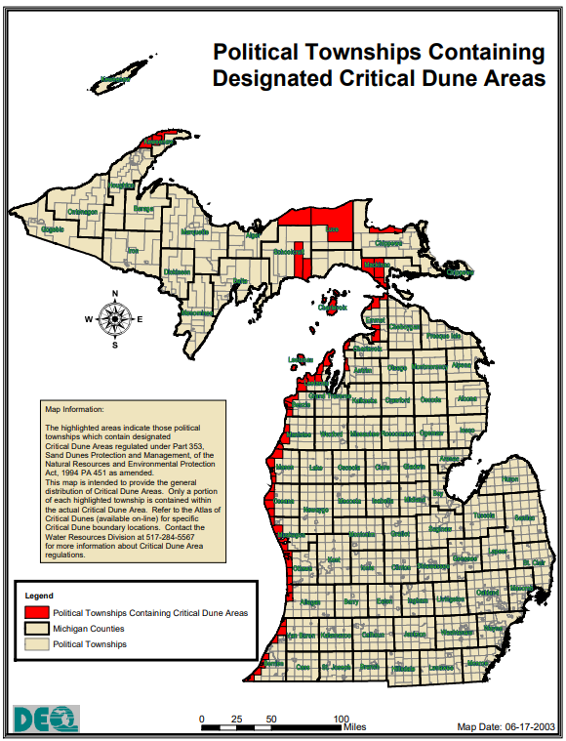
Source: Michigan.gov/egle

Climate

Northwest Michigan experiences a four season climate with mild summers and cold, snowy winters. The GTB’s lands are all located within a coastal county. Lake Michigan keeps coastal areas warmer in the winter and cooler in the summer, with less rainfall than locations further inland. Since 1991, Leelanau County has experienced the most precipitation in October with 3.91 inches on average and an average annual total precipitation of 35.54 inches. June and July share the hottest month with a mean average temperature of 92 °F, however, June has the highest temperature on record of 103 °F. February is the coldest month with a mean average temperature of -11 °F. The lowest temperature on record is -29 °F in February 2015.

On any given day, coastal areas including Leelanau County, are highly susceptible to quick, sudden changes in the weather. Depending on the time of the year, the Great Lakes have a significant impact on temperatures, precipitation, and the strength of storms. In the spring when the lake water is colder than the air over them, they extract heat from the atmosphere. During the fall, the Great Lakes give off heat and moisture. In both cases, storms arrive on land stronger and more persistent than they might otherwise be. Thunderstorms, extreme winter weather events, and excessive rainfall are common natural hazards with the potential to cause loss of life and significant property damage. This plan identifies potential hazards and mitigation strategies to reduce the impact of those disasters.

Membership

Tribal membership is located throughout the six-county region as shown in Table 2. Grand Traverse County has the highest number of Tribal members followed by Leelanau County. Manistee County has the lowest number of members.

Table 2: Membership Population by County, 2021
County | 2021 | Enrolled | % of Total
Manistee | 42 |  | 2%
Antrim | 97 |  | 5%
Benzie | 144 |  | 7%
Charlevoix | 203 |  | 10%
Leelanau | 690 |  | 36%
Grand Traverse | 766 |  | 39%
TOTAL | 1,942 | 4,189 | 46%
Source: Grand Traverse Band of Ottawa and Chippewa Indians Membership Records

Figure : Membership Population by County, 2021
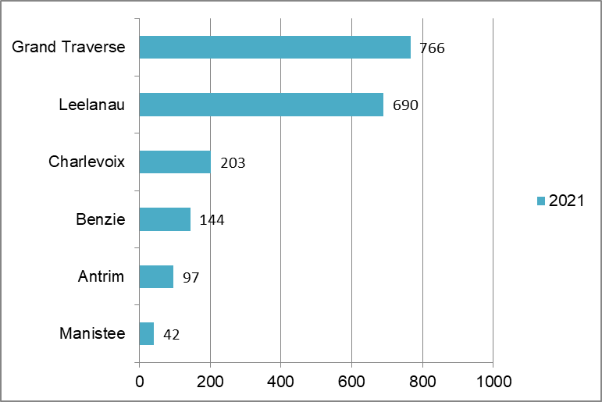
The membership’s age is recorded in Table 3. The GTB’s total 2021 population is broken into age cohorts (analyzing which proportions of the population are in which stages of life). The membership age is broken down into cohorts of members aged 0-19, 20-54, and Elders, those aged 55 and over. The table identifies the number of members within each cohort for each county. Understanding the age distribution and median age can help identify social, economic, and public service needs in the community.

Based on current membership ages overall, the Tribe is likely to increase membership due to the high percentage of persons in the family-forming age group (20-54). 53% of all members are aged 20-54. Grand Traverse County has the highest number of members and the highest number and proportion of members aged 20-54. This would indicate the membership in this county will grow in future years if persons in this family-forming age group decide to have children. Leelanau County has the second highest membership and the highest number and proportion of youth, persons aged 0-19. This is indicative of the high number of membership ages 20-54 and 55+. Persons in those age groups likely did have multiple children, thus the membership count increased. The youth cohort, persons aged 0-19, is the next highest membership category with 25% of the membership. Followed closely by Elders, those aged 55+ at 22% of the membership. While the Tribe is fairly young, there should be consideration and planning for the Elder membership in 10-20 years as those in the family-forming age group move into the Elder cohort. Members living in Benzie County are showing early signs of this as Benzie has the largest percentage of Elders and the second lowest number and percentage of youth.

Table 3: Membership Age by Cohort, County, 2021
 | 0-19 | % | 20-54 | % | 55+ | % | TOTAL
Antrim | 25 | 26% | 55 | 57% | 17 | 18% | 97
Benzie | 25 | 17% | 70 | 49% | 49 | 34% | 144
Charlevoix | 44 | 22% | 95 | 47% | 64 | 32% | 203
Grand Traverse | 178 | 23% | 451 | 59% | 137 | 18% | 766
Leelanau | 211 | 31% | 340 | 49% | 139 | 20% | 690
Manistee | 4 | 10% | 24 | 57% | 14 | 33% | 42
TOTAL | 487 | 25% | 1,035 | 53% | 420 | 22% | 1,942
Source: Grand Traverse Band of Ottawa and Chippewa Indians Membership Records

Other GTB demographic information can be collected from the U.S. Census Bureau. In 2020, population, employment, household, income, education, and health-related information was collected via the Decennial Census and the American Community Survey 5-Year Estimates for GTB Reservation and Off-Reservation Trust Land in Michigan.
- 595 Members reported in the population

Figure 5: 2020 U.S. Census Bureau Community Profile
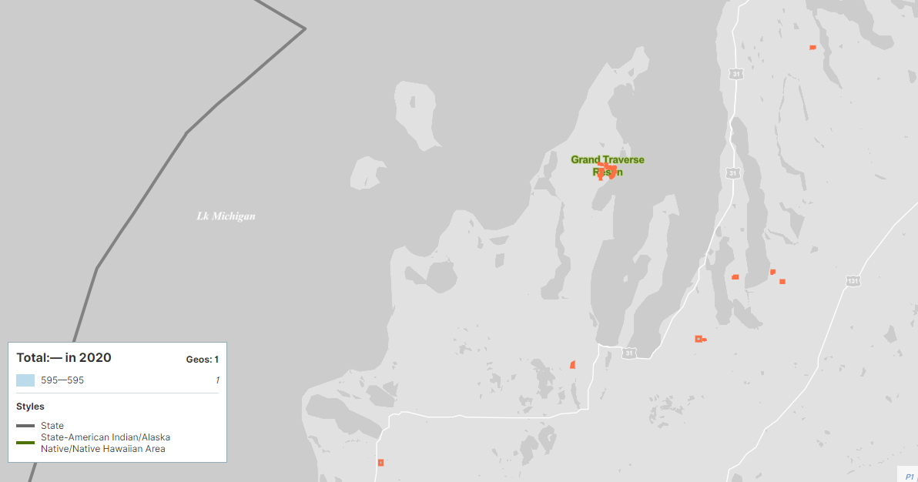
Source: U.S. Census Bureau

Housing

According to the U.S. Census, in 2020, there were 206 estimated total housing units on GTB Reservation and Off-Reservation Trust Land in Michigan. Of these, 190 were occupied, 16 were vacant. ### households were reported and the average household size was ### persons. ### of households reported living in a 1-unit structure while ### reported living in a 2-or-more-unit structure. ### of units were renter-occupied while ### were owner-occupied. The Census defines a household as all the people who occupy a single housing unit, regardless of their relationship to one another.

For purposes of this planning process, a list of membership and residential addresses was provided. Table 4 represents a breakdown of the number of residential units by county.

Table 4: Membership Housing Units by County, 2021
County | 2021 Member Housing Units | Percent of 2021 Total
Antrim County |  | %
Benzie County |  | %
Charlevoix County |  | %
Grand Traverse County |  | %
Leelanau County |  | %
Manistee County |  | %
TOTAL |  | %
Source: Grand Traverse Band of Ottawa and Chippewa Indians Membership Records

Residential development for members continues to be a main priority for the Tribe. The Herkner Road property located in Grand Traverse County features up to 193 residential units including single-family lots, single-family cottages, Elder housing, townhomes, and apartments. The site will also feature a community center, gym, pavilion, and daycare facility.

Table 5: Housing Units by Permit, 2010-2019
Year | # of Permits
2010 | 6
2011 | 12
2012 | 4
2013 | 7
2014 | 0
2015 | 0
2016 | 2
2017 | 8
2018 | 2
2019 | 0
TOTAL | 41
Source: Grand Traverse Band of Ottawa and Chippewa Indians Planning Department

The social-economic profile includes employment and income characteristics reported to the U.S. Census Bureau as shown in the following tables. Table 6 represents the occupations reported by the ### members who were employed at the time of the survey. The largest number of workers are employed in ### followed by the ### sector with ###

Table 6: Occupation by Industry, 2020
Source: U.S. Census 2020 ACS 5-Year Estimate

### households reported income and benefit information as shown in Table 7. The largest number of households reported an income of ### followed by those who reported an income level of ###.

Table 7: Household Income, 2020
Source: U.S. Census 2020 ACS 5-Year Estimate

Transportation

The GTB service area is crossed by several national and state highways: U.S. 31, U.S. 131, and state highways M-22, M-72, and M-66. U.S. 31 is a north-south route that follows the Lake Michigan coastline and connects Charlevoix and Antrim County with Grand Traverse County. U.S. 131 is an another north-south route that is more inland and connects Petoskey to Kalkaska. M-22 is a north-south corridor which runs from Northport in the north to Traverse City in the south. M-72 is an east-west corridor which runs from Empire in the west and traverses the state to end in Harrisville in the east. M-66 is north-south corridor through Charlevoix County. It follows Lake Charlevoix in the north and then meets with Mancelona in the south. Traverse City is a transportation hub where U.S. 31, M-22, and M-72 intersect. The remainder of the GTB service area is accessed via numerous county and forest roads. The area also contains many miles of seasonal roads with a number in Leelanau County being built and maintained by the U.S. Parks Service. The local County Road Commissions are the primary owner of the local street network and maintains roads within township jurisdictions.

There is currently no passenger rail service available in this region. Traverse City’s Cherry Capital Airport is the main hub for air travel, but the region also has access to Manistee County Blacker Airport in Manistee and the Charlevoix Municipal Airport in Charlevoix. Ferry travel to Beaver Island is available from Charlevoix, and ferry travel to the Manitou Islands is available from Leland. Members rely on the Arthur Duhamel Marina for access to Lake Michigan waters for fishing and recreation.

Utilities and Energy

The GTB operate water and wastewater utility services in portions of Leelanau County. The Utility Department, led by the Utility Director, was created to manage the water and wastewater systems. GTB utilities are considered critical infrastructure as indicated in Table 8 below. Recently, the Tribal Council expressed an interest in leveraging the successful self-managing wastewater system and explore a similar expansion into renewable energy.

Future Land Use

Hazard Identification and Assessments

Vulnerability Assessment

Natural hazard impact on the community can be understood by evaluating vulnerabilities for commonly agreed upon assets. A community’s assets are defined broadly to include anything that is important to the character and function of a community and can be described very generally in the following categories:

- People
- Economy
- Built environment
- Natural environment

Vulnerable populations include the economically disadvantaged, elderly, homeless, and persons with a disability. Those that live unsheltered or in homeless encampments, assisted living facilities, mobile home parks, or isolated subdivisions are more susceptible to hazardous events. Vulnerable populations are represented on the Vulnerable Populations and Hazard Areas Map in Appendix A. Those locations included on the map were specifically mentioned during public input sessions. There may be additional locations of vulnerable populations that are not listed.

As shown in Table 8, the primary economic generators for the GTB are Tribal government, Grand Traverse Economic Development, and the Grand Traverse Resort and Casinos. Government facilities are located in Peshawbestown while Grand Traverse Economic Development is located in Traverse City, and the resort and casino are located in Acme, east of Traverse City. These resources are all located along the Grand Traverse Bay and within an easy distance of each other. This concentration of population and resources make the Grand Traverse Bay area critically important economically and as a resource for community members. It is vulnerable to all countywide hazards and shoreline hazards which is further detailed in the hazard analysis. Infrastructure points (stream crossings, bridge conditions, and dams) and their ratings are mapped on the Infrastructure Map in Appendix A.

The natural environment is one of the primary features of GTB culture and traditions. Its significance shows up in different aspects of daily life and Tribal celebrations and festivals. The forest lands, water features, and shorelines and all of the wildlife within them are integral to the identity of the community. While natural resources are abundant they are vulnerable to all types of hazards. Northwest Lower Michigan is also home to many sensitive wildlife populations that require specific climates and habitats to survive. Damaged, destroyed, or changing environments may decrease the chances for certain species’ survival.

GTB critical infrastructure is represented in Table . Task Force members identified the critical facilities and infrastructure and the points were mapped on the Critical Infrastructure Points Map in Appendix A.

Table : Critical Facilities and Infrastructure
No. of Facilities | Facility Type
1 | Commercial  - Leelanau Sands Casino
4 | Emergency Services  - Fire and EMS Service
4 | Energy  - GTB Solar  - Gas Stations
25 | Government Facilities  - County Offices  - Water and Sewer System
3 | Healthcare  - Medical Offices
1 | Industry  - Bay Shore Steel Works
8 | Information Technology  - IT Offices  - Date Center
2 | Transportation  - Maritime

Source: GTB Emergency Management

On April 10, 2022 members of the GTB Hazard Mitigation Advisory Team and members of the Leelanau County Hazard Mitigation Advisory Team held a joint meeting to discuss potential hazards in the community and specific concerns with those hazards. Participants in the meeting were asked about each known hazard to the community and asked to identify their top three hazards. Table represents the tally of sticky notes gathered at the meeting. The number one hazard of concern is high winds followed by heavy snow or snowstorms.

Table : Sticky Note Exercise, Hazard Concerns
Natural Hazard Event or Impact | # of Times Indicated
High Winds | 10
Heavy Snow/Snowstorm | 8
Electrical Grid Failure | 6
Wildfire | 5
Thunderstorm/Severe Storm/Tornado | 4
Flood | 3
Dam Failure | 2
Communications Failure | 2
Road Closures | 2
Agriculture Loss | 1
Invasive Species | 1
Loss of Community Facilities | 1
Shoreline Erosion | 1
Sewer Failure | 1
Extreme Cold | 1

Historical Analysis

The Historical Analysis of weather-related hazards in Leelanau County and the surrounding service area uses information on impacts and losses from previous hazard events to predict potential impacts and losses during a similar event. Because of the frequency of these events, communities are more likely to have experience with and data on impacts and losses. These events are included in the hazard analysis for individual event types.

Table 9: Presidential and Governor Declared Disasters
Date of Incident | Type of Incident | Affected Area | Type of Declaration
3/27/2020 | Pandemic | All 83 Counties | Gov. Emergency
1/29/2019 | Extreme Cold | All 83 counties | Gov. Emergency
8/2/2015 | Thunderstorms | City of Traverse City (Grand Traverse Co.), Township of Acme (Grand Traverse Co.), Township of East Bay (Grand Traverse Co.), Township of Garfield (Grand Traverse Co.), Township of Long Lake (Grand Traverse Co.), Township of Peninsula (Grand Traverse Co.), and Township of Whitewater (Grand Traverse Co.); Grand Traverse, and Leelanau Co. | Gov. Disaster
2/13/2014 | Deep frost | Charlevoix, Cheboygan, Chippewa, Delta, Emmet, Gogebic, Luce, Mackinac, and Marquette Co. | Gov. Emergency
6/18/2013  5/7/13 | Flooding | Allegan, Baraga, Barry, Benzie, Genesee, Gogebic, Gratiot, Houghton, Ionia, Iron, Kent, Keweenaw, Marquette, Mecosta, Midland, Muskegon, Newaygo, Ontonagon, Osceola, Ottawa and Saginaw Co.; City of Grand Rapids (Kent Co.); City of Ionia (Ionia Co.) | Gov. Disaster
7/14/2008 | Thunderstorms, flooding | 12 counties: Allegan, Barry, Eaton, Ingham, Lake, Manistee, Mason, Missaukee, Osceola, Ottawa, Saginaw, and Wexford Co. | Pres/ Major Disaster (1777)
9/7/2005 | Hurricane evacuation | All 83 counties | Emergency (3225)
9/4/2005 | Hurricane evacuation | All 83 counties | Gov. Disaster
3/10/94  3/4/94  2/23/94, 2/25/94 | Underground freeze | Charlevoix, Cheboygan, Chippewa, Delta, Gogebic, Houghton, Mackinac, Marquette, Ontonagon, and Schoolcraft Co. | Gov. Emergency
12/93-5/94 | Underground freeze | 10 counties: Charlevoix, Cheboygan, Chippewa, Delta, Gogebic, Houghton, Mackinac, Marquette, Ontonagon, and Schoolcraft Co. | Pres. Major Disaster (1028)
10/28/86  9/15/86  9/12/86 | Flooding, heavy rain | Allegan, Arenac, Bay, Clare, Clinton, Genesee, Gladwin, Gratiot, Huron, Ionia, Isabella, Kent, Lake, Lapeer, Macomb, Manistee, Mason, Mecosta, Midland, Montcalm, Muskegon, Newaygo, Oceana, Osceola, Ottawa, Saginaw, Shiawassee, Tuscola, and Van Buren Co. | Gov. Disaster
9/10-19/86 | Flooding | 30 counties: Allegan, Arenac, Bay, Clare, Clinton, Genesee, Gladwin, Gratiot, Huron, Ionia, Isabella, Kent, Lake, Lapeer, Macomb, Manistee, Mason, Mecosta, Midland, Montcalm, Muskegon, Newaygo, Oceana, Osceola, Ottawa, Saginaw, Sanilac, Shiawassee, Tuscola, and Van Buren Co. | Pres. Major Disaster (774)
2/21/1986 | Great Lakes flooding, wave action | Allegan, Arenac, Bay, Berrien, Grand Traverse, Iosco, Macomb, Marquette, Menominee, Monroe, Muskegon, Ottawa, Saginaw, St. Clair, Tuscola, Van Buren, and Wayne Co. | Gov. Disaster
1/26-27/78 | Blizzard, snowstorm | Statewide | Pres. Emergency (3057)
1/26/1978 | Blizzard, snowstorm | Statewide | Gov. Disaster
3/2/1977 | Drought | 44 counties: Alcona, Alger, Alpena, Antrim, Arenac, Baraga, Benzie, Charlevoix, Cheboygan, Chippewa, Clare, Crawford, Delta, Dickinson, Emmet, Gladwin, Gogebic, Grand Traverse, Houghton, Iosco, Iron, Isabella, Kalkaska, Lake, Leelanau, Luce, Mackinac, Manistee, Marquette, Mason, Mecosta, Menominee, Missaukee, Montmorency, Oceana, Ogemaw, Ontonagon, Osceola, Oscoda, Otsego, Presque Isle, Roscommon, Schoolcraft, and Wexford Co. | Pres. Emergency (3035)
4/5/1956 | Tornado | 4 counties: Benzie, Leelanau, Manistee, and Ottawa Co. | Pres. Major Disaster (53)

Source: FEMA

Hazard Descriptions

The GTB lands and service area is vulnerable to a wide range of natural hazards. Hazard events have the potential to impact members, economic drivers in the community, critical infrastructure and the built environment, and the natural environment. The Grand Traverse Band of Ottawa and Chippewa Indian’s Emergency Management is challenged with managing these threats to protect life and property. This plan includes a profile for each natural hazard event the GTB is likely to face. Due to a concentration of facilities and members, the primary focus of the hazard analysis is events in Leelanau County. A snapshot of severe weather events for the entire Tribal service area is provided in Figure . Each profile includes the location, extent, previous occurrences, probability of future events, and vulnerability assessment.

- Location is the geographic areas within the planning area that are affected by the hazard, such as a floodplain. The entire planning area may be uniformly affected by some hazards, such as drought or winter storm. Location may be described in narrative and or through map illustrations.
- Extent is the strength or magnitude of the hazard. Extent can be described in a combination of ways depending on the hazard.
- Previous occurrences describe the history of previous hazard events within the county. This information helps estimate the likelihood of future events and predict potential impacts. The extent of historic events may be included when the data is available. Data is collected from the National Oceanic and Atmospheric Administration’s National Centers for Environmental Information data center (NOAA).
- Probability of future events is the likelihood of the hazard occurring in the future and can be described in a variety of ways. Probability may be defined using historical frequencies or statistical probabilities.
- Vulnerability assessment accounts for the types and numbers of existing and future buildings, infrastructure, and critical facilities located in the identified hazard areas and provides an estimate of the potential dollar losses to vulnerable assets identified.

Data for natural hazard events in Leelanau County was compiled from several different sources. Weather event data was collected primarily from the National Centers for Environmental Information through the National Oceanic and Atmospheric Administration’s (NOAA). All sources include:

- FEMA records of historic Presidential and/or Governor declared emergencies (Table 9)
- Tribal emergency declarations (Table 9)
- National Weather Service Climate and Past Weather
- Weather/Climate Events, Information, Assessments
- Climatology and Extreme Events
- NOAA Storm Event Database (Table 10); started at 1950 to present, however, information for various events is limited The database utilizes local storm reports, damage reports, events checked for Leelanau County included: Flood (Flash Flood, Flood),Shoreline (Lakeshore) Flood, Hail (Hail), Extreme Winter Weather (Blizzard, Freezing Fog, Frost/Freeze, Heavy Snow, Ice Storm, Lake-effect Snow, Sleet, Winter Storm, Winter Weather), Extreme Temperatures (Cold/Wind Chill/Heat/Extreme Heat), Tornado (Tornado, Funnel Cloud), Dense Fog, Thunderstorm and High Wind (Heavy Rain, High Wind, Lightning, Strong Wind, Thunderstorm Wind), Wildfire (Wildfire)
- The Michigan Hazard Analysis report by the Michigan Department of State Police in 2019 and the Michigan Department of Natural Resources was used to collect data on wildfires
- The National Inventory of Dams was used to collect information on countywide dams

The Storm Events Database is updated on a rolling basis, and thus the database is always being added to. The most up to date information was added to Table 10, but as events occur the database will change. Thus, 2022 is likely only partially represented. There were 249 events reported between 01/01/1950 and 010/1/2021. There were a total of 207 days with an event, 2 days with event and death or injury, 33 days with event and property damage, and 6 days with event and crop damage. Those events as well as the emergency declaration events are included in the hazard analysis. The hazard analysis groups the events into the following categories:

Table 10: NOAA Storm Events Database, Leelanau County Event by Type, 1950-2022
Type of Event | # of Events | Event Location
Extreme Winter Weather (Inc. Ice, Snow, Blizzard) | 133 | Countywide
Thunderstorms and Severe Winds | 62 | Countywide
Hail | 35 | Countywide
Riverine and Urban Flooding | 4
Lightning | 2 | Countywide
Shoreline Hazard(Coastal Flooding / Coastal Recession) | 3 | Coastal areas
Tornado | 3 | Countywide
Extreme Temperatures (Heat / Cold) | 2 / 2 | Countywide
Drought | 1 | Countywide
Wildfire |  | MDNR Lands
Rip Current | 1 | Coastal areas
Seiche | 1 | Coastal areas
Public Health Emergency | 1 | Countywide
Invasive Species | Ongoing | Countywide
Source: NOAA: National Centers for Environmental Information and MDNR

Figure : Severe Weather Events, GTB Service Area, 1950-2021
 |  | Grand Traverse | Antrim | Leelanau | Manistee | Charlevoix | Benzie | Total Events
Occassionally Occurring Events (1950-2021) | Dense Fog | 0 | 0 | 0 | 1 | 0 | 0 | 1
Occassionally Occurring Events (1950-2021) | Rip Current | 0 | 0 | 1 | 1 | 0 | 2 | 4
Occassionally Occurring Events (1950-2021) | Drought | 1 | 1 | 1 | 1 | 2 | 0 | 6
Occassionally Occurring Events (1950-2021) | Lightning | 2 | 2 | 2 | 2 | 1 | 1 | 10
Occassionally Occurring Events (1950-2021) | Heat | 2 | 2 | 2 | 2 | 2 | 2 | 12
Occassionally Occurring Events (1950-2021) | Tornado | 4 | 10 | 3 | 2 | 4 | 4 | 27
Occassionally Occurring Events (1950-2021) | Flooding (inland and coastal) | 10 | 2 | 6 | 10 | 4 | 4 | 36
Frequently Occurring Events (2012-2021) | Hailstorm | 11 | 8 | 6 | 6 | 6 | 3 | 40
Frequently Occurring Events (2012-2021) | High Wind/T-Storm Wind | 20 | 11 | 12 | 10 | 10 | 7 | 70
Frequently Occurring Events (2012-2021) | Winter Weather | 21 | 26 | 19 | 15 | 15 | 14 | 110
 | Total Events | 71 | 62 | 52 | 50 | 44 | 37

Source: NOAA: National Centers for Environmental Information

Economic Impact Analysis

Table presents the reported deaths, injuries, property damages, and crop damages of storm events in Leelanau County from 1950-2021. There were two deaths and zero injuries. One death occurred from a an extreme cold event on February 10, 2008, and the other death occurred from a rip current on August 30, 2012. The economic impact of Leelanau County natural hazards is $25,564,000 in property damages and $53,563,000 in crop damages since 1950 Events such as hail likely cause numerous residents small amounts in property damage, but go unreported. The total reported Damaging Events’ Costs recorded since 1950 with the National Oceanic and Atmospheric Administration for Leelanau County are as follows:

Table 11: Damage Cost by Event Type, 1950-2022
Leelanau County | Death / Injury | Property Damage Cost | Crop Damage Cost
Extreme Winter Weather | 0 / 0 | $653,000 | $50,500,000
Thunderstorm and High Wind | 0 / 0 | $24,257,000 | $8,000
Hail | 0 / 0 | $85,000 | $3,055,000
Riverine and Urban Flooding | 0 / 0 | $50,000 | $0
Lightning | 0 / 0 | $40,000 | $0
Shoreline Hazards | 0 / 0 | $179,000 | $0
Tornado | 0 / 0 | $295,000 | $0
Extreme Temperatures | 1 / 0 | $0 | $0
Drought | 0 / 0 | $0 | $0
Wildfire | 0 / 0 | $- | $-
Rip Currents | 1 / 0 | $0 | $0
Seiche | 0 / 0 | $5,000 | $0
Public Health Emergency | 0 / 0 | NA | NA
Invasive Species | 0 / 0 | NA | NA
TOTAL | 2 / 0 | $25,564,000 | $53,563,000
Source: NOAA: National Centers for Environmental Information and MDNR

Table 12 provides an overview of each potential hazard’s estimated impact on the State Equalized Values (SEV) for real and personal property (residential and commercial).

Table 12: Geographic Economic Impact by Event
Hazard Event | Geography | Population  Totals | State Equalized Value
Extreme Winter Weather, Thunderstorm, Hail, Lightning, Tornado, Extreme Temperatures, Drought | Leelanau County |  | $
Inland Flooding |  |  | $
Wildfire | Areas within Jack Pine forest |  | $
Shoreline Hazards, Rip Currents, Seiche | Coastal areas |  | $
Source: 2019 ACS Estimate, Leelanau County Equalization

Extreme Winter Weather

National Weather Service defined as: phenomenon (such as snow, sleet, ice, wind chill) that impacts public safety, transportation, and/or commerce. The Extreme Winter Weather category includes the following subcategories: winter weather, winter storm, ice storm, heavy snow, blizzard, frost/freeze, and lake effect snow. Blizzards are the most perilous snowstorms and are characterized by low temperatures, strong winds, and enormous amounts of fine, powdery snow. Snowstorms have the potential to reduce visibility, cause property damage, and loss of life.

According to the 2019 Michigan Hazard Analysis, Michigan has 360 snowstorms with 0.1 average annual deaths, 0.1 average annual injuries, and $1.9 million in average annual property and crop damage. Michigan experiences large differences in snowfall over short distances due to the Great Lakes. The average annual snowfall accumulation ranges from 30 to 200 inches with the highest accumulations in the northern and western parts of the Upper Peninsula. In Lower Michigan, the highest snowfall accumulations occur near Lake Michigan and in the higher elevations of northern Lower Michigan. For example, the average snowfall ranges from 141 inches in the Gaylord area to 101 inches in Traverse City in the northwest region of the Lower Peninsula.

Ice and Sleet Storms are storms that generate sufficient quantities of ice or sleet that result in hazardous conditions and/or property damage. Ice storms occur when cold rain freezes on contact with the surface and coats the ground, trees, buildings, and overhead wires with ice. Often times, ice storms are accompanied by snowfall, which sometimes causes extensive damage, treacherous conditions, and power loss. On the other hand, sleet storms are small ice pellets that bounce when hitting the ground or other objects. It does not stick to trees or wires, but can cause hazardous driving conditions. When electric lines are down, households are inconvenienced, and communities experience economic loss and the disruption of essential services.

According to the 2019 Michigan Hazard Mitigation Plan, Michigan has 16 average annual ice and sleet storm events with 0.2 average annual deaths, 0.5 average annual injuries, and $11.4 million in average annual property and crop damage.

Location
Extreme winter weather events are regional events that are not confined to geographic boundaries and can affect several areas at one time with varying severity depending on factors such as elevation and wind patterns. All of Leelanau County and other GTB lands are at risk to the occurrence and impacts from extreme winter weather. All counties in the GTB service area are coastal communities, and therefore, are more susceptible to lake-effect snow due to proximity to Lake Michigan.

One of the highest-impact snowstorms in recent memory pounded Northern Michigan on the night of March 2, 2012. Low pressure tracked from Missouri, to southern Lower Michigan, and on to eastern Canada, while rapidly strengthening. Precipitation surged northward into the region on the evening of the 2nd. This was primarily snow, except in parts of east central Lower Michigan (especially near Lake Huron), where temperatures were mild enough for rain. Snow wound down on the morning of the 3rd, and though somewhat blustery winds occurred behind the system on the 3rd, blowing snow was limited because the snowfall was so wet. Snow totals ranged from 6 to 14 inches across most of Northern Michigan. Higher amounts fell near and west of Grand Traverse Bay, with a maximum amount of 20 inches near Lake Ann. With relatively warm temperatures, the snow was very wet; Traverse City saw around a foot of snow during the night, with a low temperature of 33 degrees. The snow stuck to everything, with the weight of the snow downing many, many trees and power lines. Power outages were widespread, with an outright majority of Northern Michigan residents losing power at some time during or after the storm. In Benzie County, 95 percent of residents lost power. Outages lasted up to a week in some spots. Great Lakes Energy described it as the worst snowstorm (in regards to power outages) in 30 years. A number of counties and communities opened shelters to aid those without power or heat. Also included in the tree damage was substantial damage to fruit trees in the Grand Traverse Bay region, particularly cherry trees. This event accounts for $650,000 in reported damages.

The frost/freeze event on listed in Table 13 took place on April 27, 2012 across Northwest Lower Michigan. A killing freeze caused extreme damage to agriculture, particularly in the fruit belt of Northwest Lower Michigan. Traverse City saw low temperatures of 25 degrees on the 27th, 31 degrees on the 28th, and 26 degrees on the 29th. These values were not exceptionally colder than normal lows, which are in the middle 30s. Ultimately, the main culprit was a stretch of unprecedented warmth in mid-March, which included five consecutive 80-degree days (17th-21st). This caused fruit trees to bud out far, far ahead of schedule, and left them vulnerable to even relatively normal weather as the spring progressed. The tart cherry crop was a total loss, while other orchard fruits such as sweet cherries, apples, pears, and peaches saw losses in excess of 90% of the expected crop. Crop damages were reported to be $37,500,000.

Extent
Snowstorms can be measured based on snowfall accumulations or damages.

Previous Occurrences

Table 13: Extreme Winter Weather Previous Occurrences, 1950-2022
Event Type | Number of Events | Property Damage | Crop Damage | Event Year(s)
Winter Weather |  | $ | $ -
Winter Storm |  | $ | $ -
Ice Storm |  | $ | $ -
Heavy Snow |  | $ | $ -
Blizzard |  | $ - | $ -
Frost/Freeze |  | $ - | $
Lake-Effect Snow |  | $ - | $ -
TOTAL | 133 | $ 653,000 | $ 50,500,000
Source: NOAA: National Centers for Environmental Information

Probability of Future Events and Vulnerability Assessment
Since 1950, Leelanau County has had 133 extreme winter weather events. This averages to about two events every year. The probability of an event occurring in future years is 100 percent. Heavy snow events have the potential of shutting down towns and businesses for a significant period of time. Blowing and drifting snow with blizzard conditions cause driving hazards. Ice damage may occur when high winds push lake water and ice past the shoreline, causing damage to public infrastructure and residential property. The GTB grows much of its own food and a frost/freeze event of the magnitude in 2012 would decimate an essential food source.

GTB members are the primary vulnerability during winter weather-related events. The reasons for member vulnerability include: the high percentage of Elder members in some communities, the high percentage of members within poverty level, members who live in remote areas, limited access to technology including cellular phone service and broadband internet, and minimal access to backup power sources. The Community Survey specifically mentioned internet and cell access was an issue and there were concerns about access to power in the event of a natural hazard. Ice storms have the capability to take out power, and cold temperatures can be fatal for members without a backup power source. Providing help and assistance to members in remote locations can treacherous when combined with icy or snowy roads.

Comments from input session
- Ice dams along rivers/lakes can damage adjoining properties
- Food pantry can lose their supplies if the power is out.
- Agricultural products (vineyards, cropland) can be impacted if there is a late spring heavy frost, ice or hail storm. This can negatively impact the local agriculture economy and people’s personal property.
- People who aren’t aware of storm damage to their seasonal homes and return in the spring/summer to find and report damaged property (perhaps they had a roof leak or water lines that froze)
- More vulnerable residents whose homes are not well insulated could have more problems with roof damage and frozen pipes.
- 2012 storms left businesses, government and roads closed for 5 days
- Have a lack of community shelters
- Winds and ice can pull electrical lines down
- Increased potential for car accidents
- Gas stations down if they don’t have back up power
- Cell towers down causes challenges with communications
- Many people rely on wood/propane fuel to heat their homes and often live in rural areas that are difficult to access in an emergency to provide their fuel source if needed.
- Population stranded on rural properties; can’t be accessed by emergency vehicles with heavy/drifting snow or ice.
- Erratic winter weather patterns recently – less consistent.
- Extra burden and cost placed on the Road Commission and emergency services.
- 1977 Blizzard MSP/Corp of Engineers – road closures
- GTB Tribe added generators since the 2012 winter storms

Thunderstorms and Severe Winds

Severe thunderstorms are weather systems accompanied by strong winds (at least 56mph), lightning, heavy rain (that could cause flash flooding), hail (at least 3/4:” diameter), or tornadoes. Severe thunderstorms can occur at any time in Michigan, although they are most frequent during the warm spring and summer months from May through September.

Severe wind events are included in this category. Long-lived wind events associated with fast-moving severe thunderstorms are known as a derecho. A derecho often occurs during the spring or summer; however, it can occur any time of the year. According to The National Severe Storms Laboratory, winds in excess of 58 miles per hour are considered to be a derecho. Severe windstorms can cause damage to homes and businesses, power lines, trees and agricultural crops, and may require temporary sheltering of individuals without power for extended periods of time.

Location
Thunderstorms and severe wind are regional events that are not confined to geographic boundaries and can affect several areas at one time with varying severity depending on factors such as elevation and wind patterns. All of Leelanau County and the GTB area is at risk to the occurrence and impacts from thunderstorms and severe winds.

Extent
Thunderstorms can be measured based on wind speed or damages. The average wind speed for events in Leelanau County is ### knots.

Previous Occurrences
Since 1950, there have been 62 thunderstorm events accompanied by strong winds and severe wind events reported in Leelanau County (Table 14). There have been eleven thunderstorm or wind-related Presidential or Governor declared emergencies or disasters across the entire GTB area.

Table 14: Thunderstorm and Wind Events Previous Occurrences, 1950-2022
Event Type | Number of Events | Property Damage | Crop Damage | Event Year(s)
Thunderstorm Wind |  | $ | $ - | 1950-2021
High Wind |  | $ | $ -
Strong Wind |  | $ | $ -
TOTAL | 62 | $ 24,257,000 | $ 8,000
Source: NOAA: National Centers for Environmental Information

Probability of Future Events and Vulnerability Assessment
Since 1950, Leelanau County has had 62 thunderstorm events accompanied by strong winds. This averages to .86 events every year. The probability of an event occurring in future years is 86 percent. Damage from straight line winds usually affects multiple counties through the loss of electricity from trees/tree limbs downing power lines; causing widespread property damage; and potentially exposing members to severe injury or fatality due to flying debris. The magnitude and severity depend on the population, seasonal activity, and the spread of development. During the warm or summer months, friends and family visit or celebrations and festivals are held that draw a large number of visitors to the area. Those without permanent shelter or are caught outside in a quickly moving storm are vulnerable to hazardous conditions.

Comments from input session
- Power outages, trees down, wires down
  - Gas stations are closed; impacts commerce. Gas is needed to fuel generators!
  - Road closures due to downed trees, etc. prohibits EMS timely response to incidents; people can be stuck in their homes/neighborhoods. Also impacts local commerce if the roads are not able to be used to transport goods and services.
  - People living on oxygen or who have a low food supply or primarily perishable food supply are directly impacted
  - Glen Arbor, Peshawbestown and other areas of the County in 2015 – 5-day stretch without power after a thunderstorm. GTB had downed lines (they have a lot of overhead lines). Their sewer stations had pump failures at the main lift and had to supply generators to power them. Many negative impacts to commerce and transportation. Debris management is a cost to the county and to contract out at the State level.
  - Only have 1 power company in the County, which limits their ability to respond quickly to all outages in a wide-spread event.
  - Power outages are costly to emergency services and residents.
- Can result in big floods
- Lightning strikes can cause fires, impacting homes, woodlands
- Money and time spent on the extreme demand placed on local responders – pay overtime for increased manpower
- Leelanau County receives 1-2 events per year that meet the criteria of a severe thunderstorm, windstorm, hail, lightning, tornado… Given our seasonal influx of tourists and the high potential for these storms at the same time of the year this could have devastating impacts to the economy, infrastructure and environment.

Hail

Hailstorms occur when a severe thunderstorm produces hail that falls to the ground. Hail is formed when the updrafts of the storm carries water droplets above the freezing level, where they form into rounded or irregular lumps of ice that range from the size of a pea to the size of a grapefruit. When the weight of the hail is no longer supported by the air, it falls to the ground and has the potential to batter crops, dent automobiles, and injure people and wildlife. Sometimes, large hail appears before a tornado since it is formed in the area of a thunderstorm that tornadoes are most likely to form.

According to the 2019 Michigan Hazard Mitigation Plan, Michigan has on average 191 hail storms, an expected annual statewide loss of about $16.6 million, no deaths, and approximately 1 injury per year. Despite damaging hail occurring in every part of Michigan, the areas of the state most prone to severe thunderstorms (e.g. the Southern half of the Lower Peninsula) are also most prone to large and damaging hail. The majority of the hailstorms occur during the growing season from May through August when crops have the greatest potential to be damaged by hail.

According to the 2012 Michigan Hazard Analysis, the National Weather Service began recording hail activity in Michigan in 1967. The National Weather Service issues forecasts for severe thunderstorms with sufficient warning time to allow residents to take appropriate action to reduce the effects of hail damage to vehicles and some property. However, little can be done to prevent damage to crops. For example, during September 26-27, 1998, a line of severe thunderstorms moved across northern Lower Michigan producing hail up to 2” in diameter, destroying an estimated 30,000-35,000 bushels of apples at area farms, and damaging several homes and vehicles.

Location
Hailstorms are regional events that frequently accompany thunderstorms, and are not confined to geographic boundaries. The severity of hailstorms may range across the affected areas. All of Leelanau County and GTB areas are at risk to the occurrence and impacts from hailstorms. According to the National Weather Service, Leelanau County is in an area of the United States that has on average two days of hailstorm events per year.

One particularly strong event occurred on July 8, 2016 near Empire. Powerful thunderstorms developed over Lake Michigan late in morning of the 8th, ahead of an incoming cold front. These storms produced very large hail, and some damaging winds, as they swept across northern Michigan. Approximately 60 percent of the cherry crop in northwest lower Michigan was damaged by the severe thunderstorms. Golfball-sized hail was reported in Empire, and up to three inches in diameter in Glen Arbor. Some vehicles were damaged, and a few homes lost windows and skylights. Considerable damage was done to orchards and vineyards in the area.

Extent
Hailstorms are categorized using the TORRO Hailstorm Intensity Scale, which ranges from H0 (Hard Hail) to H10 (Super Hailstorms) (Table 15). According to the NOAA National Centers for Environmental Information, the approximate size of hail is described as follows:

Table 15: NOAA Hail Size Description
Appearance | Approximate Size in Inches
Pea | 0.25-0.5 inch
Penny | 0.75 inch
Nickel | 0.88 inch
Quarter | 1.00 inch
Walnut/Ping Pong | 1.50 inch
Golf Ball | 1.75 inch
Hen Egg | 2.00 inch
Tennis Ball | 2.50 inch
Baseball | 2.75 inch
Tea Cup | 3.00 inch
Grapefruit | 4.00 inch
Softball | 4.50 inch

The greatest extent hail reported in Leelanau County was 3 inches on July 8, 2016, which correlates to H6 (destructive) on the TORRO Hailstorm Intensity Scale. According to the scale, hailstones of this size are equivalent to a tea cup and can damage ground aircraft and brick walls.

Previous Occurrences
Between 1950 and 2022, Leelanau County had 35 hailstorms reported to NOAA (Table 16). There are ### damages, but no injuries or deaths attributed to hail.

Table 16: Hail Events, 1950-2022

Source: NOAA: National Centers for Environmental Information

Probability of Future Events and Vulnerability Assessment
With 35 events reported in the past 72 years, Leelanau County has a 50% chance of a major hailstorm every year. All existing and future buildings, exposed infrastructure, and populations are at risk from hailstorms since hail causes damage to roofs, brick walls, glass, landscaping, crops, and cars. Manufactured homes are located throughout the county and are more susceptible to hail damage. Hail can also damage roads, sidewalks, bridges, and above ground utilities. Hail has the potential to cause injury and death, and populations are advised to take shelter when an event occurs.

Riverine and Urban Flooding

Riverine flooding occurs when rivers, streams, and lakes overflow into adjacent floodplains due to prolonged, intense rainfall, rapid snowmelt or ice jams. Flooding can damage or destroy property, disable utilities, destroy crops and agricultural lands, make roads and bridges impassable, and cause public health and safety concerns. Floods occur in the early spring, but also occur in the winter due to ice jams, and during the summer or fall from severe thunderstorms. Flooding caused by severe thunderstorms has a greater impact on watercourses with smaller drainage areas.

Urban flooding occurs when water flows into low-lying areas because it does not have a place to go. This flooding occurs from a combination of excessive rainfall, snowmelt, saturated ground, and inadequate drainage, and is becoming more common in Michigan. Since development is occurring in floodplains, the natural landscape is unable to properly disperse the water. Urban flooding also has the potential to overflow onto docks or other structures with electricity running to them, which increases the risk for an electric shock drowning. Additionally, storm and sanitary sewers are unable to handle the water flows associated with storm events, which can result in sewer overflows and affect the water quality of nearby lakes and rivers, as well as structures with basements or shallow groundwater tables.

According to the 2019 Michigan Hazard Analysis, the most damaging hazard in Michigan, based upon estimated physical damages and known response/recovery costs, appears to be floods. The MSP reports that flooding events have a statewide expected annual loss estimated at more than $100 million ($25.69 million had previously been estimated in the 2014 Michigan Hazard Mitigation Plan, but Federal Disaster 4195 confirmed a higher magnitude more in line with earlier MDEQ estimates, as that Metro Detroit flood event was quite similar to Federal Disaster 1346 during the previous decade).

The MSP’s 2019 Michigan Hazard Analysis indicates that the Northern Lower Peninsula averages 0.3 annual flooding events, with average annual property and crop damages of $2,591,244 due to flooding. Leelanau County experienced ten flood events since 1950, with $5,020,000 in property damages. The largest was a failure by a temporary dam structure in 2012 which impacted 53 homes.

Location
Comments from input session
- The Belanger Creek Dam (at the end of Belanger Creek at the intx. with M-22)
- Belanger Creek, located southeast of Stallman Road to the outlet in the Bay – potential for overflow
- Stallman Road near the intersection with Belanger Creek, located SW of Strongheart Way.

Extent

Previous Occurrences

Table 17: Leelanau County Fluvial and Pluvial Flood Events
Source: NOAA: National Centers for Environmental Information

Probability of Future Events and Vulnerability Assessment
Floods can damage or destroy public and private property, disable utilities, make roads and bridges impassable, destroy crops and agricultural lands, cause disruption to emergency services, and result in fatalities. People may be stranded in their homes for several days without power or heat, or they may be unable to reach their homes at all. Long-term collateral dangers include the outbreak of disease, widespread animal death, broken sewer lines causing water supply pollution, downed power lines, broken gas lines, fires, and the release of hazardous materials.

The seasonal nature of flooding will continue to occur. Years with exceptional snowfall levels will likely result in flooding events from snowmelt. Lake Michigan water temperatures will create more active storm systems and heavier rainfalls. Lake Michigan water levels will also increase flooding events inland as the water table rises. Furthermore, increased development, reduction in green space, and subsequent soil erosion cause sedimentation to accumulate in river and lake beds reduce the amount of water flow. Rivers and lakes with sedimentation buildup will experience water backups and flooding events unless mitigated.

Since 1950, Leelanau County has had 4 flooding events. There is a 5.5% chance of an annual flood. The magnitude and severity depend on the area of impact’s population, seasonal activity, and the spread of development. During the warm or summer months, the population expands to include both the permanent population and visitors to the area. The seasonal population is attracted to both rural, sparsely populated rural areas and urban activity centers. Central Business Districts. with dense, urban development, including historical resources, impoverished and elderly independent and assisted living facilities are vulnerable to flooding from rivers that pass through. The Tribe holds festivals and events such as the ### which takes place ###.

Specific flood hazard areas were identified during public meetings and are identified on the Hazard Areas Map provided in Appendix A. Flood hazard information may be obtained from the Flood Rate Insurance Maps (FIRM) available for jurisdictions. In order to delineate potential flood plain areas (seasonal floodplains) for each jurisdiction, Networks Northwest overlaid wetland, soils, and elevation data to determine the most likely flood prone areas. Once overlaid; isolated polygons (areas) were deleted in order to show a more accurate representation of potential flood prone areas along lakes, rivers, and streams. Sources: Temporary/Seasonally Flooded Areas data are from the National Wetland Inventory of the US Fish and Wildlife Service; and Digital Elevation Model data are from Leelanau County.

NFIP Participation Status
The Little River Band of Ottawa Indians is not a participating community in the National Flood Insurance Program.

The following communities in Leelanau County and Grand Traverse County are participants in the program:

Lightning

Lightning is a random and unpredictable discharge of electricity in the atmosphere between the clouds, air, or ground to equalize the charged regions in the atmosphere. It is still being debated how the electrical charges build up in the clouds. Lightning generally occurs during thunderstorms; however, it can occur without a thunderstorm, such as during intense forest fires and heavy snowstorms. Lightning that occurs without nearby rain is most likely to cause forest fires.

Location
Lightning is not confined to geographic boundaries and is a regional event. Since lightning occurs randomly, it is impossible to predict where lightning will occur and how severe it will be. All of Leelanau County and the GTB service area is at risk to the occurrence and impacts from lightning.

Extent
Lightning can be measured by damages-caused including deaths, injuries, property damages, and/or crop damages. Since 1950, two lightning events have been reported to NOAA in Leelanau County. Those events have caused $40,000 in property damage, no crop damages, no injuries, and no fatalities.

Previous Occurrences
There have been two lightning strikes reported to NOAA since 1950. There have been no fatalities. There have been no other reports of damages or injuries from lightning. Table 18 is a record of lightning events in Leelanau County.

Table 18: Lightning Events
LOCATION | DATE | DEATHS | INJURIES | PROPERTY DAMAGE
 |  | 0 | 0 | $0
HIGH |  | 0 | 0 | $0
TOTAL |  | 0 | 0 | $0
Source: NOAA: National Centers for Environmental Information

Probability of Future Events and Vulnerability Assessment
Since there have been two lightning events reported in the last 72 years, the data shows that there is a 3% chance a lightning strike would occur every year. However, not all lightning events may have been reported since events with injuries, deaths, and extensive damages tend to be the only ones reported. Therefore, the number of lightning events and damages may be higher.

All existing and future buildings, exposed infrastructure, and populations are at risk from lightning events since it may cause structural and wildland fires, loss of electrical and telecommunications equipment, and damage to buildings or vehicles from falling trees struck by lightning. People that work outside or participate in outdoor recreation activities are at a higher risk to be struck by lightning.

Tornado

A tornado is a violently rotating column of air that extends from a thunderstorm to the ground, and can occur anytime during the day and throughout the year. It can only be seen if water droplets, dust, and debris form a funnel. The funnel cloud can have winds that reach up to 300 miles per hour with an interior air pressure that is 10-20% below the surrounding atmosphere’s pressure. The length of a tornado path has been reported up to 200 miles. Tornado path widths are generally less than one-quarter mile wide. These storms are the most violent of the atmospheric storms since they have the potential to destroy buildings, uproot trees, hurl objects, and cause loss of life.

According to the National Oceanic and Atmospheric Administration/National Weather Service’s Storm Prediction Center, tornadoes cause approximately 60 deaths and hundreds of millions of dollars in property damage each year. According to the 2019 Michigan Hazards Plan, Michigan is located on the northern fringe of the nation’s tornado belt and has a statewide expected annual loss of about $19.6 million due to tornadoes. Michigan also has an average of 18 tornadoes, approximately 4 deaths, and approximately 50 injuries per year. Between 1999 and 2019, Michigan has had 314 reported tornado events with 52.9% as EF0 (weak) or EF1 (moderate), 38.9% reported as F0 or F1 (weak), 6.7% as EF2 (significant) or EF3 (severe), and 1.6% as F2 (strong). In Northern Michigan, tornados are most likely in the summer months, although some have occurred in the spring and fall.

Location
Tornadoes are a regional event that are not confined to geographic boundaries and can affect several areas at one time. Also, the magnitude of tornadoes may range across the affected areas. All of Leelanau County and the GTB service area is at risk to the occurrence and impacts from tornadoes. It should be noted that it is impossible to predict where and with what magnitude a tornado will touchdown.

Table 19: Tornado Events
LOCATION | DATE | MAGNITUDE | DEATHS | INJURIES | PROPERTY DAMAGE
 |  |  | 0 | 0 | $
 |  |  | 0 | 0 | $
 |  |  | 0 | 0
TOTAL |  |  | 0 | 0 | $295,000

Extent
The Fujita Scale (Table 20) categorizes tornado severity based on observed damage. The six-step scale ranges from F0 (light damage) to F5 (incredible damage). As of February 2007, the National Weather Service uses the Enhanced Fujita Scale (EF Scale). This new scale ranges from EF0 to EF5. Based on the Fujita Scale, Leelanau County’s most damaging tornado occurred on ### with winds ranging from ### mph. It caused no injuries or deaths, but $ ### in property damages.

Table 20: Fujita and Enhanced Fujita Scale Comparison
Fujita Scale |  | EF Scale
Fujita Scale | 3-Second Gust Speed (mph) | EF Scale | 3-Second Gust Speed (mph)
F0 | 45-78 | EF0 | 65-85
F1 | 79-117 | EF1 | 86-109
F2 | 118-161 | EF2 | 110-137
F3 | 162-209 | EF3 | 138-167
F4 | 210-261 | EF4 | 168-199
F5 | 262-317 | EF5 | 200-234
Source: FEMA

Previous Occurrences
Between 1950 and 2021, Leelanau County has had three (3) reported tornadoes touchdown, causing a reported $ 295,000 in property damage (Table 19). As a result of these tornadoes, there were no deaths, no injuries, and no reported crop damage. One of the tornadoes caused $ ### in damage, the most destructive of the two. The second tornado caused $### in property damages.

Probability of Future Events and Vulnerability Assessment
Since there have been three tornadoes events reported in the last 72 years, the data shows that there is a 4% chance a tornado would occur every year. While the chance for a tornado is low, if an event occurs, there is potential for a higher magnitude tornado to touch down. All reported historic events have caused significant property damage. Due to increased residential growth in the county, the chances of a tornado touching down and causing residential damage is very high, especially in Traverse C and surrounding townships where population densities are highest.

Sirens and shelters…###

Extreme Temperatures

Prolonged periods of very high or very low temperatures are often accompanied by other extreme meteorological conditions, such as high humidity, drought, heavy snowfall, or high winds. Extreme heat or extreme cold primarily affect the most vulnerable segments of the population, such as the elderly, children, impoverished individuals, and people in poor health.

Nationwide, there have been approximately 175 deaths per year that are attributable to extreme heat according to the 2019 Michigan Hazard Analysis. The threats from extreme heat are heatstroke, sunstroke, muscle cramps, heat exhaustion, and fatigue. It is hazardous to livestock and agricultural crops, causes water shortages, exacerbates fire hazards, exacerbates respiratory problems, prompts excessive electrical energy demands, and causes infrastructure failures. Urban areas experience the most serious extreme heat with the combined high temperatures and high humidity that produce a heat-island effect.

According to the 2019 Michigan Hazard Mitigation Plan, Michigan has 11 average annual extreme heat events with 0.4 average annual deaths and 41 average annual injuries.

In the United States, approximately 700 people die each year as a result of severe cold temperature-related causes according to the 2019 Michigan Hazard Analysis, with a significant number of deaths occurring due to illnesses or disease that are negatively impacted by severe cold weather, such as stroke, heart disease, and pneumonia. Exposure to extreme cold temperatures can be life threatening and can cause hypothermia and frostbite. According to the 2019 Michigan Hazard Mitigation Plan, Michigan has 35 average annual extreme cold events with 1 death, 9.4 average annual injuries, and $6.4 million in average annual property and crop damage. Extreme cold affects transportation modes and power utilities, resulting in dead vehicle batteries and loss of power/heat.

Measuring Extreme Temperatures (Extreme Heat and Extreme Cold)
Extreme heat is measured with the National Weather Service’s Heat Index Chart (Figure ). The chart uses relative humidity and air temperature to determine the likelihood of heat disorders with prolonged exposure or strenuous activity. Individuals are unable to shed excess heat from their bodies when they experience prolonged exposure to hot temperatures, which results in heat disorders.

Figure : National Weather Service Heat Index
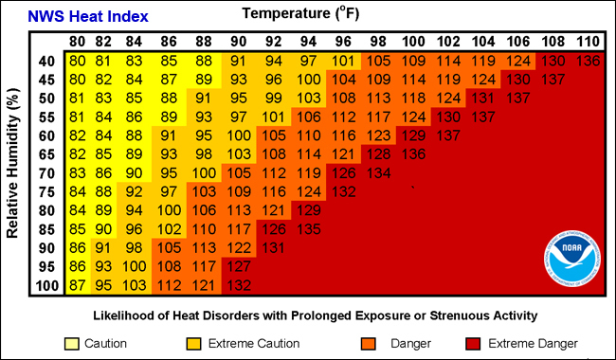
Source: National Weather Service

Extreme cold is measured with the wind chill index, which is a measure of the rate of heat loss from exposed skin caused by the combined effects of wind and cold. As the wind increases, heat is carried away from the body and reduces the external and internal body temperatures. Figure shows the NOAA Wind Chill Chart as it corresponds to various temperatures and wind speeds.

Figure : National Weather Service Wind Chill Chart
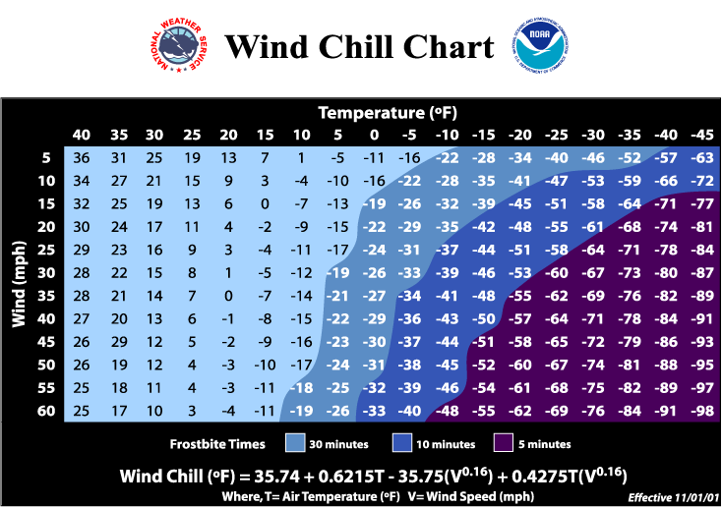
Source: National Weather Service

Figure are the observed temperatures in Leelanau.

Figure : Daily Temperature Data:

Source: NOAA Climate Data Online

Location and Extent
Extreme temperatures are a regional event that are not confined to geographic boundaries and range in severity across the affected areas. All of Leelanau County and the GTB service area is at risk to the occurrence and impacts from extreme temperatures.

Since 1950, there have been two extreme cold events reported in Leelanau County. The first occurred on

The second instance of extreme cold occurred on

The third and last instance of extreme cold is the Governor Declared Emergency that occurred on January 29, 2019. Wind chills of 15 to 30 below zero were common in northern lower Michigan. Wind chills were much colder in eastern upper Michigan, including -51 at Kinross, and -42 at Sault Ste Marie and Mackinac Island.

Previous Occurrences
Leelanau County has had two extreme heat events in

Table 21: Heat Related Events
Source: NOAA: National Centers for Environmental Information

Since 1950, there have been two extreme cold events reported in Leelanau County (Table 22).

Governor Declared Emergency for extreme cold in the State was enacted in 2019 and included all 83 counties in the state.

Table 22: Cold Related Events
Source: NOAA: National Centers for Environmental Information

Probability of Future Events and Vulnerability Assessment
Since 1950, there have been two extreme heat events in Leelanau County. This data shows approximately one extreme heat event would occur every 36 years. Since 1950, there have been three extreme cold events in Leelanau County. This data shows approximately one event would occur every 24 years. Since extreme cold events tend to occur during the winter months and are coupled with blustery winds and snowstorms, these events may have been reported as other hazards or not at all, which means there may have been more extreme cold events in the county.

Extreme heat and cold events are more likely to impact unsheltered populations. The urban homeless population is especially vulnerable. The Northwest Lower Michigan Coastal Resilience Atlas written by the Land Information Access Association completed a Heat Vulnerability Assessment of coastal communities. A community’s vulnerability is their exposure to the hazard (determined by tree canopy and impervious surface coverage) + their sensitivity. Sensitivity is determined by the folowing factors:

    - Persons > 65 years
    - Persons living alone
    - Minority (non-white) persons
    - Persons living below the poverty threshold
    - People > age 25 with less than a high school education
    - Disability status (i.e., ambulatory difficulty, mental disability)

The GTB Elder population…

Figure 10: GTB Lands/ Township Relative Sensitivity of Population to Extreme Heat Events

Source: LIAA Northwest Lower Michigan Coastal Resilience Atlas

Comments from input session

Extreme Heat/Drought
- Brine on roads for dust control
- Electric grid is burdened by draw from lots of AC unit use
- Wildfire risk increases
- Crop and agricultural loss – orchards, vineyards, dairy and beef cattle
- Dehydration and heat stroke, especially in elderly and tourist populations
- Reduction in lake levels
- Concerns for fisheries, agriculture and livestock
- Extreme heat a concern for people who work outside.
- Need cooling shelters, welfare checks for vulnerable populations
- Increased demands on emergency services
- Possibly fewer tourists if it’s too hot, or an increase in tourism creating a lack of resources for year-round citizens.
- Brine roads to keep dust down but is expensive and doesn’t last long
- Excessive water usage; GTB has 3 wells at TCC; 2 at GTR; 2 wells on farms and 3 in Peshawbestown.

Drought

Drought is a normal part of the climate cycle. It is a slow-moving hazard, which causes people to underestimate the damage it can do, but losses from drought are as substantial as those from hurricanes, tornadoes and other faster-moving disasters. Drought causes losses to agriculture; affects domestic water supply, energy production, public health, and wildlife; and contributes to wildfire, to name a few of its effects.

Location
Drought is a regional event that is not confined to geographic boundaries and range in severity across the affected areas. All of Leelanau County and the GTB lands are at risk to the occurrence and impacts from drought.

Extent
The Palmer Drought Severity Index (PDSI) uses readily available temperature and precipitation data to estimate relative dryness. It is a standardized index that generally spans -10 (dry) to +10 (wet). Maps of operational agencies like NOAA typically show a range of -4 to +4, but more extreme values are possible. The PDSI has been reasonably successful at quantifying long-term drought.

The U.S. Drought Monitor (Figure 11) combines several input sources including the PDSI and the Standardized Precipitation Index to prepare a weekly map showing parts of the U.S. that are in drought. The map uses five classifications: abnormally dry (D0), showing areas that may be going into or are coming out of drought, and four levels of drought: moderate (D1), severe (D2), extreme (D3) and exceptional (D4) (Figure 12).

Figure 11: Leelanau County Historical Drought Levels

Source: US Drought Monitor

Figure 12: U.S. Drought Categories and Historically Observed Impacts
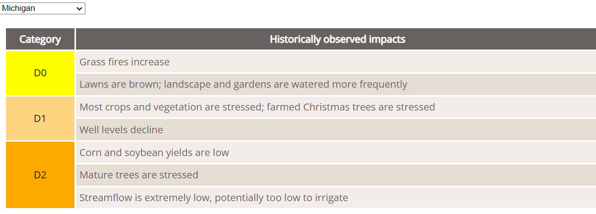
Source: US Drought Monitor

Previous Occurrences
Since 1950, there has been one instance of drought in Leelanau County. The event was a Presidential Declared Emergency for drought problems in the State was enacted in 1977 and included Leelanau, Lake, Mason, Oceana, and Wexford Counties.

Probability of Future Events and Vulnerability Assessment
There is a 1.4% annual chance for a drought event in Leelanau County. In Northern Michigan’s forested regions, drought can adversely impact timber production and some tourism and recreational enterprises. This can also cause a drop in income, which impacts other economic sectors. The biggest problem drought presents, however, is the increased threat of wildfire. Western and southern portions of Leelanau County are heavily forested and are therefore highly vulnerable to drought-related wildfire threats. Additionally, the threat to water sources should also be considered. Many county residents rely on ground water wells for drinking water. Even drought events in category D1 experience water well level decline. Drought events combined with excessive heat can have severe impacts on elderly and low income people.

Wildfire

A wildfire is an unplanned, uncontrolled fire in grassland, brushland, or forested areas. Wildfires can occur in any forest or grassland type under dry conditions; however, some forest types are more susceptible to wildland fires. For example, jack and red pine forest stands have a high risk for wildfires, as they dependent on fire to provide all the right conditions for regeneration, while aspen and white pine forest stands have a moderate risk. The primary cause of wildfires is from human activities, specifically burning outdoor debris. Wildfires cause destruction to property and timber resources, and injuries or loss of life to wildlife and persons living or recreating in wildfire prone areas. Long-term effects include scorched and barren land, soil erosion, landslides/mudflows, water sedimentation, and loss of recreational opportunities.

Approximately 55% (20.4 million acres) of Michigan’s total land area is forest cover. The vast forests provide Michigan with the largest state-owned forest system in the United States. In addition, Michigan has the fifth largest quantity of timberland acreage, with 19.3 million acres (including hardwoods and softwoods). That vast forest cover is a boon for both industry and recreation, and these areas have been gradually increasing in recent years. However, it also means that many areas of Michigan are vulnerable to wildfires.

Michigan’s fire season starts in early spring, when leaves and grasses remain dry from fall and winter and trees are not yet green. Wildfires are often accompanied by drought where dry conditions increase the potential to burn. Often a thunderstorm will roll through and lightning will strike causing sparking of dry leaves and dead wood. High winds can then spread wildfire. Wildfires can become unpredictable in windy conditions or when the wind changes direction suddenly. Cooler nighttime temperatures often help suppress wildfires and the potential for wildfire; however Michigan has had several major fire events.

According to MDNR and U.S. Forest Service records, between 1910 and 1949, over 5.8 million acres of forest were burned, an average of 145,000 acres per year. By comparison, it was reported that between 1950 and 1996, the MDNR and U.S. Forest Service were involved in suppressing over 46,100 wildfires that burned 390,000 acres of forest, which averages only 8,300 acres burned per year. This drastic reduction in the acres of timber burned was largely the result of (1) increased use of specialized equipment to suppress the fires, and (2) intensified efforts toward fire prevention.

However, lightning strikes are not the primary cause of wildfires in Michigan. Recently, only about 4% of all wildfire in Michigan were caused by lightning strikes, and most other causes have been attributed to human activity. Outdoor debris burning is the leading cause of wildfires in Michigan. Most Michigan wildfires occur close to where people live and recreate, which puts both people and property at risk. The immediate danger from wildfires is the destruction of property, timber, wildlife, and injury or loss of life of persons who live in the affected area or who are using recreational facilities in the area.

Location
All GTB communities and developed areas are vulnerable to wildfires since the community centers and rural residential developments interface with the high risk forest types (e.g. Red Pine, Eastern White Pine, and Jack Pine).

Comments from input session
- Putnam Road, east of Peshawbestown Rd., where the Natural Resources building, Fire Station and residences are located.

Extent and Previous Occurrences
Extent can be measured by the number of acres burned and the cost of property damage. Between 1996 and 2017 there were no wildfires reported outside of MDNR lands in Leelanau County. Between 1981 and 2018 there were ### reported fires on lands under MDNR jurisdiction. This resulted in ### acres burned and ### acres burned per year. No property damages were recorded.

Probability of Future Events and Vulnerability Assessment
There is a 100% chance there will be a wildfire on MDRN lands, and a small chance there will be a wildfire on lands outside of MDNR jurisdiction. Forest types (Red Pine, Eastern White Pine, and Jack Pine) within Leelanau County are susceptible to wildfires. Additional factors that increase fire risk include dead or dying Ash trees as a result of disease/invasive species, lightning strikes, and human factors such as the number of persons residing, camping, or traveling through the County. Historically, Michigan’s landscape has been shaped by wildfire; however, over the last several decades, the current landscape has transformed from wildland to residential development. With the increase in residential development in and around rural areas prone to wildfires, there is an increase in the potential for loss of life and property damage. Unfortunately, rural areas do not have enough fire suppression forces available to protect every structure from wildfires. Residential development in rural Leelanau County is often isolated from town centers and emergency services. Those subdivisions that are located in rural areas near Jack Pine forests are identified on the Vulnerable Populations and Hazard Areas Map in Appendix A.

Rip Current

Rip currents are powerful, channeled currents of water flowing away from shore. They typically extend from the shoreline through the surf zone, and past the line of breaking waves. Typically, they form at breaks in sandbars, and also near structures, such as jetties and piers, as well as cliffs that jut into the water. Rip currents are common and can be found on most surf beaches, including the Great Lakes and Gulf of Mexico.

Location
Rip currents are a coastal event that is not confined to geographic boundaries and may occur anywhere in Lake Michigan waters. All coastal areas are at risk to the occurrence and impacts from rip currents.

Extent
The National Weather Service provides a Surf Zone Forecast to measure the risk level associated with rip current hazards. Surf Zone Forecasts contain three levels of Rip Current Outlooks:
- Low Risk: The risk for rip currents is low, however, life threatening rip currents often occur in the vicinity of groins, jetties, reefs, and piers.
- Moderate Risk: Life threatening rip currents are possible in the surf zone.
- High Risk: Life threatening rip currents are likely in the surf zone.

Rip currents can be measured by damages-caused including deaths and injuries. There has been one significant rip current event in Leelanau County, and one death was reported.

Previous Occurrences
3

Probability of Future Events and Vulnerability Assessment
One rip current event has occurred in the past 72 years. There is a 1.4% of a rip current event happening every year. Rip current events are likely to occur more frequently, but go unreported as injuries and deaths do not occur. Rip currents are dangerous to all swimmers, especially those who are unprepared to be swept up in the current. Many Lake Michigan beaches do not have a lifeguard on duty who may identify potential hazardous swimming conditions. Swimmers who are caught unaware may panic when caught up in the fast-moving water, tire as they try to swim against the current, and drown.

Seiche

Shoreline Hazards (Coastal Flooding and Coastal Recession)

Shoreline hazards include coastal flooding and coastal recession. Coastal recession (subsidence) is the wearing away of land, such as loss of riverbank, beach, shoreline, or dune material. It is measured as the rate of change in the position or displacement of a riverbank or shoreline over a period of time. Short-term erosion typically results from periodic natural events, such as flooding, hurricanes, storm surge, and windstorms, but may be intensified by human activities. Long-term erosion is a result of multi-year impacts such as repetitive flooding, wave action, sea level rise, sediment loss, subsidence, and climate change. Death and injury are not typically associated with erosion; however, it can destroy buildings and infrastructure. Waters of the Great Lakes may cause shoreline hazards to occur making the entire northwest Michigan coastline is susceptible to shoreline hazards. As indicated in Figure , large portions of the Lake Michigan shoreline throughout west Michigan are identified as “High Risk Erosion Areas in 2019.”

Figure : Great Lakes Shorelines with High Risk Erosion Areas, 2019
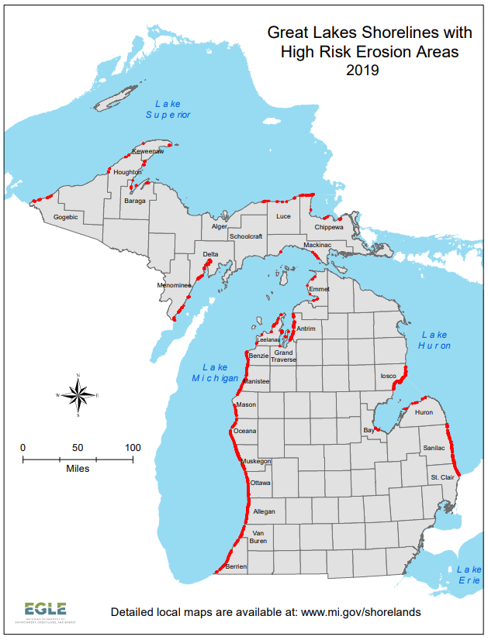

Shoreline flooding results when water levels rise and push inland or during rainfall or snowmelt accumulates and is not able to drain properly. Shoreline flooding may also be caused during storms and wind events with high-energy waves. In developing the Northwest Lower Michigan Coastal Resilience Atlas, scenario planning was used to determine the potential impact of three differing levels of storms combined with high waters. The three scenarios are described as follows:

The first scenario, “Lucky” Future: Under the Lucky Climate Future, Great Lakes water levels will continue to stay relatively low. Although there will be wave and wind action, major storm events and wave impacts will not encroach on properties landward of current beaches. A Lucky Future projection, indicating the land areas that would be affected by high-energy waves along the shorefront and/or adjacent riverine flooding under these conditions, is shown in green on the maps.
“Expected” Future: Under the Expected Climate Future, Great Lakes water levels will continue to fluctuate according to long-term decadal patterns, including recent extreme storm events incorporated into the ongoing Great Lakes Coast Flood Study being conducted by the Federal Emergency Management Agency (FEMA). Given those ongoing fluctuations, this Climate Future accounts for periods when Great Lakes still-water elevations are closer to the long-term average. In addition, this Climate Future anticipates the so-called “100-year storm event” (or 1% storm) becoming more like a 20- or 50-year storm event (i.e., an expected storm within the normal community planning time horizon) because of increased storminess. The Expected Future projection is shown in yellow on the maps.
“Perfect Storm” Future: Under the Perfect Storm Climate Future, Great Lakes water levels will continue to fluctuate according to decadal patterns, consistent with assumptions made for the Expected Future. However, for this Perfect Storm Climate Future, the estimated still-water elevation is set higher than the long-term average and closer to the long-term high (583 feet). In addition, this Climate Future anticipates the occurrence of a so-called “500-year storm event” (or 0.2% storm) occurring within the planning time horizon while lake levels are high. The Perfect Storm Future projection is shown in red on the maps.

Location
To reference the Northwest Lower Michigan Coastal Resilience Atlas, “Climate scientists predict that northwest Lower Michigan can expect more frequent storms of increasing severity in the decades ahead. The total amount of rainfall per year in also likely to increase. The potential for substantially larger rain events and severe storms raises concerns of harm to human health and damage to buildings and infrastructure, especially for areas along the Lake Michigan coastline.”
The Land Information Access Association documented potential shoreline hazards for Leelanau County communities in the Northwest Lower Michigan Coastal Resilience Atlas. Specific areas of shoreline hazards were identified during public input sessions. These are marked as a hazard area on the Hazard Area Map in Appendix A.

Source: LIAA, Northwest Lower Michigan Coastal Resilience Atlas

More specifically, three events have been reported. The first (although nor recorded in the Storm Events Database) occurred on February 21, 1986 during the last major high water event prior to 2019. A Governors Disaster Declaration for shoreline problems in the State was enacted in 1985-1986 and included Leelanau County.

The second event occurred on

The third event occurred on

Comments from input session
- 3 areas of concern along the shoreline; one is near a gas station – possible contamination source if impacted by rising lake levels

Figure 13 describes the three potential flooding scenarios in the Peshawbestown. “Lucky” scenario flooding is shown in green, “Expected” flooding scenario is shown in yellow, and “Perfect Storm” future scenario is shown in red.

Figure 13: Panel #208 Flooding Hazard, Peshawbestown

Coastal recession or erosion to Lake Michigan communities is a constant, but very small wearing away of the shoreline. The Great Lakes are estimated to lose one foot of shoreline per year to normal wave and wind activity. However, storms and increased wave activity have caused increased coastal recession to varying degrees in Lake Michigan coastal communities. Chapter 4 of the Northwest Lower Michigan Coastal Resilience Atlas describes bluffline recession since its recorded shoreline in 1938. The blue line indicates the shoreline in 1938, the green line indicates the bluffline in 1938, the yellow line is the bluffline in 2016, and the red line is the predicted 30 year bluffline.

Figure 14: Panel #200 Shoreline Recession, Peshawbestown

Source: LIAA, Northwest Lower Michigan Coastal Resilience Atlas

Extent
Shoreline recession can be measured by feet of bluffline retreat and property damages. Bluffline retreat distances vary across the county, and there are no reported damages from bluffline recession. Shoreline flooding can be measured by flood water levels, inches of rainfall, lake water levels (shown in Figure 15), and damages. The four Lakeshore Flooding events in 2019 and 2020 caused $### in property damages in Leelanau County (Table ).

In recent years, the swings in water levels have been unprecedented. In January 2013, Lake Michigan-Huron set an all-time record low of 576.02 feet, and seven years later in July of 2020 Lake Michigan-Huron reached a monthly record high of 582.22, only second to the October 1986 monthly record high of 582.35.

Figure 15: Lake Michigan-Huron Historic Water Levels, 1918-2021

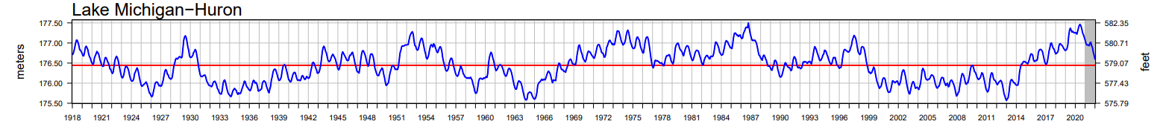

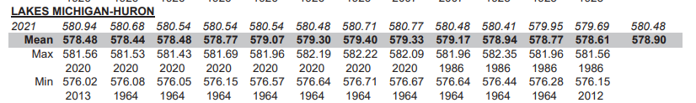
Source: US Army Corps of Engineers

Previous Occurrences
The Great Lakes experienced record high lake levels in 1985-86, and again in 1997-98. The Great Lakes experienced record high lake levels again in 2019. Many cases of erosion are present and high lake levels causing rivers and tributaries to back up have caused infrastructure damage and failures throughout Leelanau County and many other areas in Michigan. There are no recorded events related to shoreline erosion.

Table : Shoreline Flooding Events

Probability of Future Events and Vulnerability Assessment
There is a ### % chance of shoreline flooding and an equally small chance erosion will cause shoreline damages. Shoreline or soil erosion hazards involve the loss of property or necessitate the relocation of homes as sand or soil is removed by flowing water (lake, river, etc.) and carried away over time. The foundation of a structure, or underground utility pipes in the area, may become fully exposed and vulnerable to weather, extreme temperatures, water damage, or other sources of risk. Shoreline banks that support roadways may erode and cause the road surface to crack, become unstable, or more prone to deposits of sand, snow, water, and ice. This hazard is especially relevant to those municipalities that contain residential and commercial development along Lake Michigan that experience seasonal shifts in water levels and possible ice erosion hazards.

As lake water levels fluctuate and increased storminess occurs, shoreline recession and flooding will continue. In 2021 the levels of Lake Michigan-Huron began to decline, however, as historic data shows us, the water will begin to rise again. Those communities that have already faced shoreline hazards are likely to experience issues in the future. Changes in land use practices and improvements to the shoreline such as natural vegetation plantings or shoreline armoring may reinforce the shoreline for a period of time, but is likely not a permanent solution.

Public Health Emergency (Infectious Disease)

Public health emergencies occur when there is a widespread and/or severe epidemic, contamination incident, bioterrorist attacks, or other situation that negatively impacts the health and welfare of the public. These emergencies include disease epidemics, large-scale food or water contamination incidents, extended periods without adequate water and sewer services, harmful exposure to chemical, radiological or biological agents, and large-scale infestations of disease-carrying insects or rodents. A common characteristic of public health emergencies is that they impact or have the potential to impact a large number of people either statewide, regionally, or locally in scope and magnitude. These health emergencies can occur as primary events or as secondary events from another hazard or emergency (e.g. flood, tornado, or hazardous material incident).

Location
Public Health Emergency can be a worldwide, national, state or regional event that is not confined to geographic boundaries and range in severity across the affected areas. All of Leelanau County is at risk to the occurrence and impacts from an infectious disease. Depending on the type of disease, different populations are more susceptible.

Extent
The extent of a public health emergency can be determined by the number of cases and deaths, and the amount of money spent to prepare for and respond to public health threats. In Leelanau County, the Benzie-Leelanau District Health Department, works with local, state, and federal agencies to prepare for and respond to public health threats. State of Michigan (https://www.michigan.gov/coronavirus/stats) reports, as of August , 2022, there are ### cumulative cases of COVID-19 and ### deaths. Of the ### deaths with details provided, those 80 years and older have the most deaths of any age range at ### deaths. All of the deaths reported were persons 50 years and above. COVID-19 originally appeared in January 2020

Previous Occurrences
Throughout the years, there have been many pandemics. For example, there was an outbreak of severe acute respiratory syndrome (SARS) in 2003. This virus was a new coronavirus that resulted in over 8,000 illnesses worldwide. Of these, 774 died. Since 2012, Middle East respiratory syndrome (MERS), a coronavirus, has been reported in 27 countries where there have been approximately 2,494 people infected and 858 deaths. In 2017, the World Health Organization (WHO) put SARS and MERS on its priority pathogen list to spur further research into coronaviruses. More recently in 2020, a Presidential and Governor Emergency was declared for COVID-19 Pandemic in Michigan. Variants of the corona virus are still being found two years after the initial spread; vaccinations are available to limit the reaction from exposure and limit the spread of the disease.

Probability of Future Events and Vulnerability Assessment
Naturally occurring pandemics may result in widespread precautions around the world. The Tribe created a pandemic plan that serves as a template for responding to a large-scale outbreak of influenza and other highly infectious respiratory diseases. That plan is currently being tested, and the response is ongoing to this pandemic. The elderly, immune-compromised, and low income populations are most vulnerable to public health emergencies.

Comments from Input Session
- Shortcomings/ Problems
  - Located so far “up north” that they didn’t have the resources and equipment needed to service large populations of sick people
  - Exposed reliability on Munson Healthcare hospitals – limited capacity of beds
  - They typically do not stockpile resources because they do not have the funds to do so.
  - Munson – mental stress on workers, constantly changing COVID protocols.
  - Effects of isolation, work stress…increased behavioral health problems in the community. There is a lack of mental health resources to support everyone.
  - This was a long process and taxed EM/Healthcare workers with protocol changes; difficult to inform people of what recommendations and rules were as they changed frequently.
  - The economic impact from reduced services/shutdown on businesses, housing, and EMS/healthcare. Need to plan for sustainability in these areas in a future scenario.
  - Still dealing with supply chain issues – vehicles and equipment down in EMS/Fire/Road Commission fleet because can’t get repair parts.

- What Worked Well

  - Benzie-Leelanau Health Dept. testing and vaccination clinics – set up and service delivery – positive feedback
  - GTB – Health Dept. – positive feedback on vaccination and testing clinics and case monitoring. Collaboration with local, state, and federal partners.
  - Specific fire/EMS teams were dispatched to handle emergencies that were COVID-related. Had ambulances set up to only handle COVID patients.
  - They had never gone through this public health scenario before but they got what they needed.
  - Had agreements and good coordination with other EMS departments for staffing – could share staff if one dept. was short staffed. Also coordinated with use and sharing of COVID-specific ambulances.
  - Municipalities managed to the election process with health protocols
  - Zoom meetings improved communication processes and will continue to be used in combination with in-person meetings

Invasive Species

The National Invasive Species Council defines an invasive species as, “A species that is not native and whose introduction causes, or is likely to cause, economic or environmental harm or harm to human health.” The Council was formed under Presidential Executive Orders 13112 and 13751 to prevent the introduction and spread of invasive species, and to support efforts to eradicate and control invasive species that are established throughout the United States. NOAA’s National Ocean Service identifies invasive species as “capable of causing extinctions of native plants and animals, reducing biodiversity, competing with native organisms for limited resources, and altering habitats.” Invasive species harmful to Michigan and GTB Tribal lands may be either terrestrial invasive species (TIS) or aquatic invasive species (AIS).

Terrestrial invasive include non-native, land-based plants, insects, animals and diseases that harm Michigan’s environment, economy, and human health. Aquatic invasive (water-dwelling) species include non-native plants, animals, and other organisms that have evolved to live primarily in water (aquatic habitats) rather than on land. Aquatic habitats are habitats that are covered with water all or part of every year.

The GTB Wildlife Division strives to preserve, protect, and enhance native plant communities and wildlife populations important to the Tribe and its membership. To promote native plant species and protect the ecosystems they rely on, Wildlife Division staff manage Tribal properties by removing invasive plant species, such as autumn olive, Russian olive, spotted knapweed, and honeysuckle, among others. Invasive plants may outcompete native vegetation for space and nutrients so removing them reduces their risk of establishing monocultures and frees up resources for native species. Invasive plants are very persistent and often require multiple treatments to eradicate them. Therefore, this has been an ongoing multi-year project for the Wildlife Division, but the table below highlights work done over the past year. Wildlife Division staff also plant native species to help restore natural ecosystems and promote biodiversity.

Location
Combined, terrestrial and aquatic invasive species may be present in the entire six county service area including forest, wetland, farmland, grassland, aquatic, shoreline, and urban environments. “A Field Guide to Invasive Plants of Aquatic and Wetland Habitats for Michigan” (Campbell, Higman, Slaughter, Schools) identifies the Lake Michigan coastline as particularly vulnerable. “Lake-moderated climates along the Lake Michigan shoreline, Saginaw Bay, the Thumb, Lake St. Clair, and western Lake Erie are much milder than those in the state’s interior… These areas have the potential to harbor species typically found far south of Michigan.”

Extent
According to the State of Michigan 2013 Aquatic Invasive Species State Management Plan, “Since the 1800s, at least 182 nonindigenous aquatic organisms have colonized habitats of the Great Lakes ecosystem. These species include: algae (27), vascular plants (55), invertebrates (66), fish (28), and bacteria and viruses (6) (National Oceanic and Atmospheric Administration 2011). Roughly 55% of these species are native to Eurasia; 13% are native to the Atlantic Coast.” The Great Lakes Regional Collaboration estimates that a new aquatic invasive species arrives in the Great Lakes at a rate of one every eight months. GTB has allocated $$$ of the 2021 budget to treating affected areas. ### acres were treated from 2020-2021.

Previous Occurrences
Non-native terrestrial and aquatic species are introduced to Michigan and the Great Lakes both intentionally and unintentionally. Aquatic invasive species are the result of unwanted fish and aquatic plants released from home aquariums, travelled across the ocean in ballast water carried by freighters, or entered from the ocean through human-built channels such as the Welland Canal. There are 32 AIS specifically listed in the State Management Plan. The State TIS Management Plan lists fourteen species including insects, mollusks, plants, mammals, a shrub, and a bird. Top priority plants in the region include garlic mustard, Japanese knotweed, invasive phragmites, and Oriental bittersweet.

Probability of Future Events and Vulnerability Assessment
The Great Lakes and connecting channels and rivers form the largest surface freshwater system in the world. This freshwater system, along with Michigan’s inland lakes, streams, rivers, and wetlands represent an invaluable resource and are therefore justifiably a top natural resource management priority. The State of Michigan estimates 42% of threatened or endangered species are considered at risk due to non-native species. The Michigan Department of Environment, Great Lakes, and Energy produced the “Michigan Watch List Aquatic Invasive Plants: A Guide for Identification” for those species that have been identified as posing an immediate or potential threat to Michigan’s economy, environment, or human health. Included in the watch list are ten species that have been found in limited parts of Michigan and surrounding states. The State TIS Management Plan provides a list of eleven terrestrial species on the watch list. The Wildlife Division may coordinate with the Northwest Michigan Invasive Species Network and Leelanau Conservation District and other partners “protect, enhance, and promote Northwest Michigan’s natural communities through terrestrial invasive plant management and outreach.”

Comments from Input Session
- Crowding out forests – Wooly adelgid; pests and diseases that affect ash, beech, maple trees
- Aquatic invasives damaging the Great Lakes ecosystem/local fishing.
- Considering what trees from southern latitudes to plant up here because they are adapted to our current climate. ½ the plant species that were here 30 years ago are gone due to climate change.
- Fisheries – invasive mussels; algal bloom on lake bottom causes fish not being able to spawn.

Impacts from Climate Change

Climate Change Impact of Natural Hazards
With increasing global surface temperatures the possibility of more droughts and increased intensity of storms will likely occur. As more water vapor is evaporated into the atmosphere it becomes fuel for more powerful storms to develop. More heat in the atmosphere and warmer ocean surface temperatures can lead to increased wind speeds in tropical storms. Rising sea levels expose higher locations not usually subjected to the power of the sea and to the erosive forces of waves and currents.

According to the World Meteorological Organization, “A disaster related to a weather, climate or water hazard occurred every day on average over the past 50 years – killing 115 people and causing US$ 202 million in losses daily, according to a comprehensive new report from the World Meteorological Organization (WMO). The number of disasters has increased by a factor of five over the 50-year period, driven by climate change, more extreme weather and improved reporting. But, thanks to improved early warnings and disaster management, the number of deaths decreased almost three-fold.” (source)

How has Climate Change impacted the Tribe?

How will Climate Change impact the Tribe?

What is or should the Tribe be doing to prepare for Climate Change?

Goals and Objectives

What are the long-term outcomes you want to see?

2015 GOALS

Goal 1: Increase local awareness and participation in natural hazards mitigation strategies
- Encourage cooperation and communication between planning and emergency management officials
- Encourage additional local governmental agencies to participate in the natural hazards mitigation process
- Encourage public and private organizations to participate
- Encourage use of the “Firewise Communities Program” (www.firewise.org) which offers both workshops and web-based interactive training geared toward homeowners, forestry professionals, firefighters and others on a variety of wildfire safety topics.

Goal 2: Integrate natural hazards mitigation considerations into the community’s comprehensive planning process
- Enforce and/or incorporate natural hazards mitigation provisions in building code standards, ordinances, and procedures; and into the county’s comprehensive master plan
- Incorporate natural hazards mitigation into basic land use regulation mechanisms
- Update or create zoning ordinances to reflect any new building codes, shoreline protection rules, etc.
- Incorporate natural hazard area classifications into standard zoning classifications
- Develop community education and warning systems
- Integrate natural hazards mitigation into the capital improvement planning process so that public infrastructure does not lead to development in natural hazard areas
- Encourage county agencies to review local roads, bridges, dams, and related transportation infrastructure for natural hazards vulnerability

Goal 3: Utilize available resources and apply for additional funding for natural hazards mitigation
- Provide a list of desired community mitigation measures to the State for possible future funding
- Encourage the application for project funding from diverse entities

Goal 4: Develop and complete natural hazards mitigation projects in a timely manner
- Encourage public and business involvement in natural hazards mitigation projects

Mitigation Strategies and Priorities

Mitigation strategies are agency-specific actions intended to reduce the risk to natural hazards and disasters

Summarized into four main types:

- Local Planning and Regulations
- Structure and Infrastructure Projects
- Natural Systems Protection
- Education and Awareness Programs

At least one strategy for each natural hazard type.

Jolanda completed a review of the 2016 Plan strategies.

All strategies will include the following information to encourage implementation.

Priority and Action Strategies | Responsible Parties | Timeframe | Priority

Implementation

Appendix A: GTB Infrastructure, Vulnerability, and Hazard Maps

Appendix B: Community Survey Results

Appendix C: Local Planning Team Meeting Documentation

Land Information Access Association. (2019). Northwest Lower Michigan Coastal Resilience Atlas. http://www.resilientmichigan.org/nw_atlas.asp

